KADUNA POLYTECHNIC

PROJECT ON
ROAD VEHICLE BREAKDOWN ASSISTANCE

BY
BOLAJI OLAGOKE
CST20HND0444

DEPARTMENT OF COMPUTER SCIENCE
SCHOOL OF APPLIED SCIENCE
COLLEGE OF SCIENCE AND TECHNOLOGY
KADUNA POLYTECHNIC
KADUNA, NIGERIA.

JULY 2023.
KADUNA POLYTECHNIC

ROAD VEHICLE BREAKDOWN ASSISTANCE

BY
BOLAJI OLAGOKE
CST20HND0444

THIS PROJECT IS SUBMITTED TO THE DEPARTMENT OF COMPUTER SCIENCE KADUNA POLYTECHNIC IN PARTIALFULMENT OF THE REQUIREMENTS FOR THE AWARD OF HIGHER NATIONAL DIPLOMA IN COMPUTER SCIENCWE

DEPARTMENT OF COMPUTER SCIENCE
SCHOOL OF COMPUTER SCIENCE
COLLEGE OF SCIENCE AND TECHNOLOGY
KADUNA POLYTECHNIC
KADUNA – NIGERIA

JULY 2023
DECLARATION
I hereby declare that the project has been conducted solely by me under the guidance of MR. MURTALA MUHAMMAD CHAFE, department of COMPUTER SCIENCE, Kaduna Polytechnic, Kaduna and I have neither copied someone’s work nor has someone else don’t it for me. Authors whose works have been referred to in this project have been acknowledged.

______________________ ____________________ __________________
(Student Signature) (Phone Number) (Date)

APPROVAL
This is to certify that this is an original work undertake by BOLAJI OLAGOKE with Reg No. CST20HND0444 and has been prepared in accordance with the regulations governing the preparation and presentation of projects in Kaduna Polytechnic.

__________________________________________________________________________
Mr. Murtala Muhammad Chafe
Project Supervisor Name

___________________________________________________________________________
Mrs. Hafsat Moral
Head of Department Name

__________________________________________________________________________
External Examiner
DEDICATION
I dedicate this project to almighty God and my parent for their love and support throughout the project and to my supervisor that guide me on it.
ACKNOWLEDGEMENT
My since gratitude goes to almighty God for the guide he has given to me since the day I was born up to now and to my parent for their support, love and care that they have show me and to my supervisor Mr. Murtala Muhammad Chafe for his time he give to me throughout for making correction and guide to make the project a successful one may God keep protecting and guide him may he never know sadness in life. and finally my since greeting to my friends Richard Emmanuel, Faisol Ademola, Abdulsalam Ahmad Tijani for their help, support and contribution throughout the project thanks to you all.
TABLE OF CONTENTS
CONTENTS PAGES
Title Page…………………………………………………………………………………...i
Cover Page………………………………………………………………………………….ii
Declaration………………………………………………………………………….………iii
Approval…………………………………………………………………………….……...iv
Dedication…………………………………………………………………………….……v
Acknowledgment…………………………………………………………………………..vi
Table of Contents………………………………………………………………....………..vii
List of Figures……………………………………………………………………………...viii
List of Figures……………………………………………………………………………...ix
Abstract………………………………………………………………………..…….……..x
CHAPTER ONE INTRODUCTION
  - Background of Study…………………………………………………....1
1.2 Statement of Problem……………………………...……………....….....2
1.3 Aim and Objectives of the Study……………………………………......3
1.4 Scope and Limitation of the Study………………….……………..…….3
1.5 Significant of the Study………………………………...………….….....3
CHAPTER TWO LITERATURE REVIEW
2.1 Introduction…………………………..………………….………..….....4
2.2 Review of Related Past Works………………………………………....4
2.3 Related Work on Location…………………………………………......6
CHAPTER THREE PROPOSED METHODOLOGY
3.1 Introduction……………………………………………………..….….8
3.2 System Modelling …………………………………………….…….....8
3.2.1 Use Case Diagram……………………………………………..……….8
3.2.2 Activity Diagram……………………………………………………….10
3.2.3 Class Diagram…………………………………………………….12
3.3 Database Design…………………………………………………..........12
3.3.1 Sqlite3……………………………………………………...…………...13
3.4 Input and User Interface Design………………………….…………….14
3.5 System Requirement………………………………………...………….17
3.5.1 Hardware Requirement……………………………….…………………17
3.5.2 Software Requirement…………………………….……………....…….17
3.6 Programming Language Used………………….……………………….17
3.6.1 Flutter……………………………………….………………………..….17
3.6.2 Uses of Flutter…………………………….………………………….….18
3.6.3 Benefits of Flutter……………………..…………………………..…….18
3.6.4 Flutter Flexibility………………...………………………………...……18
3.7 Python…………………………..……………………………………….19
3.7.1 Django………………………..…………………………………………19
CHAPTER FOUR SYSTEM IMPLEMENTATION AND EVALUATION
4.1 Introduction……………………………………………….………….…20
4.2 System Testing Evaluation………………………………………….…..20
4.3 System Conversion Plan………………………………………………...20
4.4 System Installation………………………………………………………21
4.5 Security Measures……………………………………………………….21
4.6 Program Sample Outputs………………………………………………..21
4.7 System Performance…………………………………………………....29
CHAPTER FIVE SUMMARY, CONCLUSION AND RECOMMENDATION
5.1 Summary………………………………………………………………..30
5.2 Recommendations………………………………………………………30
5.3 Conclusion…………………………………………………………...….30
REFERENCES……………………………………………………………….31
APPENDICES………………………………………………………………..33

LIST OF FIGURES
FIGURE PAGE
Figure 3.1 Use Case Diagram 9
Figure 3.2.1 Driver Activity Diagram 10
Figure 3.2.2 Mechanic Activity Diagram 11
Figure 3.3 Class Diagram 12
Figure 3.4 Onboard Screen 14
Figure 3.4.1 Login Page 14
Figure 3.4.2 Register Page 15
Figure 3.4.3 Driver Home Page 15
Figure 3.4.4 Mechanic Request Page 15
Figure 3.4.5 Mechanic Dashboard 16
Figure 3.4.6 Update Page 16
Figure 3.4.7 Available Request 16
Figure 3.4.8 Request Page 16
Fig: 4.6 Onboarding 22
Fig: 4.6.1 Landing 22
Fig: 4.6.2 Register 23
Fig: 4.6.3 Login 23
Fig 4.6.4 Mechanic Dashboard 24
Fig: 4.6.5 Mechanic Update Page 24
Fig 4.6.6 History Page 25
Fig 4.6.7 Status Page 25
Fig 4.6.8 Driver Dashboard 26
Fig 4.6.9 Sidebar Interface 26
Fig 4.6.10 Driver request page 27
Fig 4.6.11 Driver request history 27
Fig 4.6.12 Connection Time Out 28
Fig 4.6.13 Update Profile Error 28
Fig 4.6.14 Pending Request Error 29

LIST OF TABLES
TABLE PAGE
Table 3.3.1.1 User Table 12
Table 3.3.1.2 Mechanic Table 12
Table 3.3.1.3 Driver Table 12
Table 3.3.1.4 Request Table 12
Table 3.3.1.5 Location Table 13
ABSTRACT
It is difficult to find mechanics nearby wherever you are travelling, the main objective is to provide a better service and to make the process easy in searching for a mechanic quickly. On road vehicle breakdown assistance system is going to be a good solution for the people who seek help in the remote locations with mechanical issues of their vehicle. This system helps to overcome this issue by providing mechanic details in one click. Here the locator allows you to search for legally approved mechanics from different locations. Proposed system is accessed by three entities namely, Admin, Mechanic and User. Admin is allowed to access and manage mechanic details; a mechanic can perform task such as viewing request received from users and can also send feedback to the admin. User can send a request and can appoint a mechanic on respective date-time and update their feedback about the availed services. This research work will be a mobile-based application and will be implemented using flutter for it frontend while Django will be used for the backend and Django REST Framework for it REST-full API, Sqlite3 will serve as the database, the combination of the above technologies forms the programming languages.

CHAPTER ONE
INTRODUCTION
1.1 Background of Study
The majority of car user have roadside car breakdowns when we are traveling. The worst experience they can have is this. The user must look for a mechanic and locate a spare-parts store when their vehicle unexpectedly breaks down on the road. We had to find other transportation at that time because we couldn't look for a reliable repair. With the help of this program user can locate a qualified mechanic.
Travelling is a delightful experience which everyone is experienced so we plan ahead but due to unforeseen situations there may be complications to our vehicles the application will use the user's current location to decide the nearest mechanic workshop or their garage available and display all the remaining mechanic shops in ascending order of the distance from the user. When we take the situation of Vehicle breakdown there are different aspects which can cause problems that lead to injuries and fatalities. A person with extensive practical understanding of automobiles can save your life in such circumstances, according to The Vehicle Breakdown Road Assistance (Surekha, T.2021).
Locator gives accurate information about nearest garage or workshop facilities around a particular area allowing users to reduce the amount of time required searching the mechanic garage once the incident happens. The Mechanics in our vicinity have also contributed to our project and in some areas we collected their information, such as the contact number, Owner of the shop, Address of the shop, Types of services provided by them, the shop establishment year etc. In this web application if the user is accessing the application for the first time then they are needed to register. When the details are submitted after registration they receive a confirmation link to their registered mail address to activate their account. After that they will need to login to their dashboard, when the dashboard shows and the user is required to provide their location. The user is presented the stores that are close by based on their input. Dijkstra's Algorithm is used to retrieve information about the closest mechanic shop based on the user's current location. In order to get to the destination, the user might proceed along the path Surya, (G., & Barath, S. 2021).
On Road Vehicle Assistance System they are more knowledgeable and for personal safety on the road as well. Contacting the Car Repair Service Providers is the main concern at this point as the public has limited information to the providers. All these happen on the road as the drivers will get panicked when cars break down and they have no idea who to seek for help. The scammers take advantage of this and make their service looks convenient, but it is actually a scam. From the above problems, it is important that further investigations should be made to solve this problem faced by the public. There must be a solution to this problem, not just to decrease the tow truck scam incidents, but to help the public to contact a trustworthy service operator to assist them in such situations too. The other interesting part is that, travelers can use this application since they are just few taps away to communicate the problem and get immediate possible assistance. In this crazy world with amazing technology, everyone is using Smartphone. People with android phones and tablets can install our application and can have access to our assistance service when needed (Harsha Supare 2020).
On Road Vehicle Breakdown Assistance (ORVBA) is going to be a good solution for the people who seek help in the remote locations with mechanical issues of their vehicle. Users of the On Road Vehicle Breakdown Application will be the registered public and they will be getting connected with the particular mechanic through the trustworthy application system. Because only the legally licensed and approved mechanics are enlisted in the On Road Vehicle Breakdown Assistance (ORVBA) system. In an existing system there are users who have their own mechanic database which is very minimal. And also they have no idea if their vehicles are broke down or had any mechanical issue in remote locations or any long distant locations from their known mechanic shops. In an proposed Here the users of On Road Vehicle Breakdown Application (ORVBA) system can search for list of mechanic at any location or the nearby locations which will help them in an unexpected situations raised by the mechanical issues of their vehicles. A lot of people a difficulties getting help when their breaks down on the road. Many of them do not have any car repair service providers contact number and could not get help as the car repair service center might be away from their location this project to help those who are in need when their car break down along the roads (Bavithra, M. 2020).
1.2 STATEMENT OF PROBLEM
When a vehicle breaks down while on road, the only option is to hunt for alternative transportation until a mechanic can be dispatched to the specific place where they left their car. In the existing system there are users who have their own mechanic contact details and it is also difficult for them to arrive in time or might not been close to them at that time. The only way is to look for any other transportation at that time of issue and then they need to get a mechanic to the particular location at which they have left their vehicle.
1.3 Aim and Objectives of the Study
The aim of this project is to develop a mobile application that provide vehicle breakdown assistance system for mechanic and driver.
OBJECTIVES:
- To provide a better service and to make the process easily and finally appointing a mechanic quickly.
- To proposed system is accessed by three entities namely, Admin, Mechanic and Driver.
- To build a common platform that will connect both mechanic and driver.
- To allow drivers search for mechanics around them without stress.
1.4 Scope and Limitation of the Study
The project focus areas are that any motorist may seek assistance from mechanics nearby, even if the driver is unsure of where in the environment he or she would find themselves. The technician can reach the driver without much difficulty. This project is limited due to time constraints, the application is only able to provide users with the ability to obtain mechanic help whenever their automobile breaks down.
Limitation of the Study
- This project does not support online payment.
- The project does not allow chat within the app.
- For the mechanics the project use the location of the place when they signup as their shop address.
1.5 Significance of the Study
The app stands for Road Vehicle Breakdown Assistance and a way for every driver to find solution for his/ her car breakdown while on journey it help them to reduce stress for finding mechanic in the area there don’t know much about with this app it make things goes easy for them.
- The Drivers: to request for any nearby mechanics assistance when their car has fault.
- The Mechanics: to accept or reject requests from drivers and render them their services.

CHAPTER TWO
LITERATURE REVIEW
2.1 Introduction
A look at different review of related to this project to solve or get some information that will help when doing the project and to know what was the problems of the existing system and to be able solve part of this problems.
2.2 Review of Related Past Works
Babu, U (2021): The user should give their location and details around an area are based up on the distance which are calculated by Google maps and are shown as messages. They also provide EMI calculator. Before requesting for service it is checked that the user are not automated if so they are not accepted. When the user requests it is placed automatically based their needs. The needs of the customer changes based on the situation. The system begins by allowing users to sign up for the website through standard registration form and also through Gmail. After that based on user’s current location it is shown on Google map. Website also gives Login and Registration and data is kept on Firebase database which provided by Google. They use maps to observe the garages whether mechanics are busy working or idle. The system starts from the customer, where a problem arises and the related vehicle details will be noted for service and are stored. Along with these details, user credentials will be delivered to the mechanic shop in that area. The mechanic will get a list of customer service requests based on shortest distance algorithm the data displays the closest customer who need assistance first and remaining customers in that particular format. Django is a Web Framework obtained from Python Programming Language. This Framework takes care most of the tedious work so we concentrate on writing our web application without the need of starting from the scratch. For the development of the front end of the project it has been made friendly to user with better use of HTML, CSS and JS. The back end has been written in Python Programming Language. Web development with Python is popular and sophisticated because of its readability, efficiency and security. In this review they system was build base on website which not everybody knows how to go about on a site, so with this am hoping to build it base on mobile application which it will be easy for every user, the programming language their use was complicated which require a lot of coding to build the site and it consume more time to finish it. The programming language I will be using for it if Flutter for the front end, sqlit3 for the back end and Django will still be use to manage it due to the security it has.
Pranita P. Deshmukh, Mr. Yash S. Puraswani, Mr. Aditya D. Attal, Mr. Prasad G. Murhekar, Mr. Vivek A. katole, and Mr. Vidhitya M. Wankhade (2020): The main objective of this research is to design a system that can be easily installed and to provide platform for fast access. When a user is online, the mobile app will automatically track his current position and save it in the database. M. When a user searches for a service provider, a list is provided and kept on the user's mobile device, enabling him to access service providers closest to his last known location even if his mobile device is out of service due to a vehicle breakdown.
Akhila V Khanapuri et al (2015) proposed that there has been an exponential increase in the number of cars on road, number of road accidents and vehicle breakdown cases recorded. Finding effective ways to achieve maximum fuel efficiency without hampering the internal structure of these vehicles along with providing a response system to combat mishaps is a challenging task. Main objective is to design a system that can be easily installed and to provide platform for fast access.
Elakkiya R, and Bavithra M. (2020): This system solves the problem of people who seek help in the remote locations with mechanical issues of the vehicle. This system allows users to search for list of mechanic at any location or the nearby locations which will help them in an unexpected situations raised by the mechanical issues of their vehicles. The application directs the user to the nearest emergency service as specified by the user. It also provides these services' contact information. This approach simplifies the user experience and outperforms the existing system in critical situations like this.
Surya G. and Barath S. (2021): The system developed is an android application, Android studio was used to design the frontend and Firebase for the backend. With this system, vehicle users can find mechanics’ location easily and also spare-parts shops. The limitation of the system are: Only private vehicle owners can use it, users can only edit username and not email or password.
Sathwik Krishna. L, Siva Rama Krishna. S, Abdul Amjad. S, Mahesh Babu. U, Lakshmi and Surekha. T (2021): The goal is to create a Django application that will enable users to contact nearby mechanics and request assistance through the application. The application determines the closest mechanic workshop or garage based on the user's current location and list all other mechanic shops in ascending order of distance from the user. The Dijkstra algorithm is used to determine the shortest route between the user (source) and the closest mechanic shop (destination). Distances between each shop are calculated here, and the store with the shortest distance is produced as the output, and the path from source to destination is shown. The system is a web-based; FLUTTER, DJANGO and SQLITE3 were used for the frontend while Python (Django) was used for the backend.
2.3 Related Work on Location
Adi Azlan Mohd Ali 2017: The proliferation of location services and location determination in mobile devices had broaden the landscape for the development of heterogeneous Location-based Services (LBS). The correlation of LBS applications, mobile devices and facilitating technology is a complex issue due to its diversity, hence there are immense contextual definitions of LBS. This study, review the applications and services of LBS in order to provide a common classified LBS applications and services to date, Location-Based Services (LBS) has revolutionized in location-based technologies and geospatial information during the recent decade and a large number of theoretical and empirical findings of LBS are already ubiquitously present in our everyday lives. Although LBS is a mature field of research [2], the demand to bring location-specific and personalized services and information accessible with mobile devices to users is still huge. LBS is allowing users to receive up-to-date information about their surroundings, save time and money, and make better, informed real-time choices while enabling businesses to prosper with their customer relationships and profit generation [1]. In general, LBS is a tool for profit to a broad profit making organization and at the same time, it fits with the needs of all users regardless of their demographic profiles (Adi Azlan Mohd Ali 2017).
There are numerous researches that are utilizing smart devices for the shake of technological advancements, others for the creation of a new innovative service that can revolutionize the customer experience and enhance VR experiences (Foth et al. 2009). The minority are literature review papers that are determining the studies that have the highest impact and separate the categorization and the field of each one in order to be further utilized in future work (Kárník and Streit 2016).
The field of LBS lack of researches that focus simultaneously on both the technology stream and the research stream based on stable frameworks and theories (Khruahong etal. 2018). As a result, this field opens significant opportunities for researchers that want to explore Behavior of end users in addition to an innovative solution to approximation location problems such as IPS (Wu, Kao, and Yang 2012).
Also, the managerial implications of the current research in LBS seems to be left behind comparing to other relevant disciplines such as information systems-oriented researches (Rinaldi 2009). There seems to be another gap on the management perspectives and consequences of the Location Based User Generated data that can unlock new insights on the managerial enchantments that can be utilized for research purposes (Tiru et al. 2010) (Azlan et al. 2017).
Indoor location technologies applied inside libraries can better explain behavioral characteristics that are relevant to book content and the provided services on specific areas of every library (Von Stülpnagel and Schmid 2019). Classification of books is made easier and faster, as is the control of the availability and the demand for thematic units and specific text content. Researchers can identify the days and hours that libraries are facing their higher demand and optimize their offering services for better results (Liu and Hsu 2018).

CHAPTER THREE
PROPOSED METHODOLOGY
3.1 Introduction
This chapter covers the system model (use case, activity and class diagrams) of the project and the higher-level solution (programming language) approach used.
3.2 System Modelling
A technical representation of the system is analysis models. It serves as a connection between the design model and the system description. Information, behavior, and system functions are specified in analysis modeling and converted into architectural, component, and interface level designs in design modeling.
3.2.1 Use Case Diagram
Use-case diagrams give a system's high-level operations and domain. These diagrams show how the system's actors interact with one another. Use-case diagrams' use cases and actors describe what the system does and how the actors use it, but they do not explain how the system functions inside.

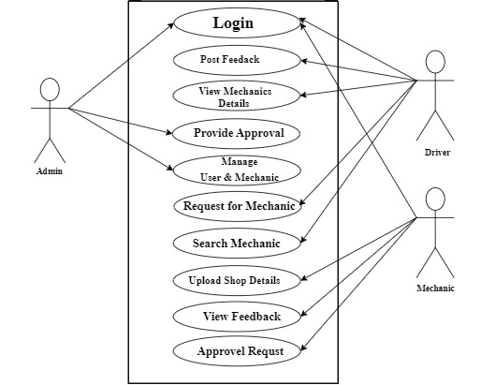

Figure 3.1 Use Case Diagram

3.2.2 Driver Activity Diagram

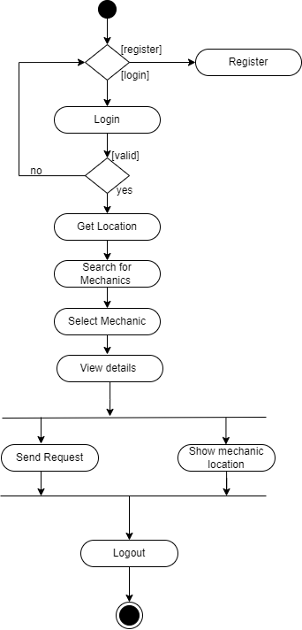

Figure 3.2.1 Driver Activity Diagram

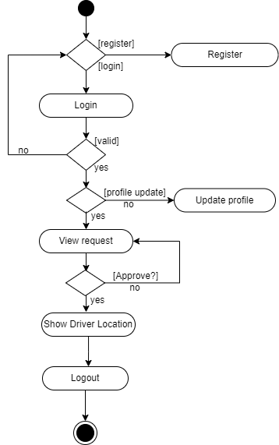

Figure 3.2.2 Mechanic Activity Diagram

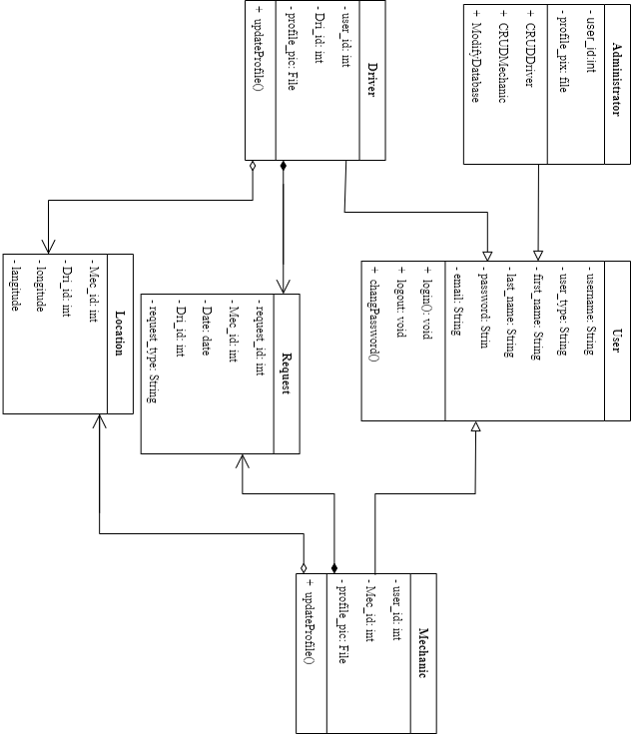
3.2.3 Class Diagram

Figure 3.3 Class Diagram
3.3 Database Design
Provides you with access to up-to-date, accurate information. Because a correct design is essential to achieving your goals in working with a database, investing the time required to learn the principles of good design makes sense. In the end, you are much more likely to end up with a database that meets your needs and can easily accommodate change.

3.3.1 Sqlite3
Sqlite is use to design the database for this project, which means that’s the place all the information well be save for all the users.
Table 3.3.1.1 User Table
FIELDNAME | DATATYPE | LENGTH | KEY
Username | Sting | 8 | Primary key
user_type | String | 20 | -
first_name | String | 20 | -
Last_name | String | 20 | -
Password | String | 6 | -

Table 3.3.1.2 Mechanic Table
FIELDNAME | DATATYPE | LENGTH | KEY
User_id | int | 8 | Foreign Key
Mec_id | Int | 8 | Primary Key
Profile_pic | File | - | -

Table 3.3.1.3 Driver Table
FIELDNAME | DATATYPE | LENGTH | KEY
User_id | int | 8 | Foreign Key
Mec_id | int | 8 | Primary Key
Profile_pic | File | - | -

Table 3.3.1.4 Request Table
FIELDNAME | DATATYPE | LENGTH | KEY
Request_id | int | 8 | Primary Key
Mec_id | int | 8 | Foreign Key
Dri_id | int | 8 | Foreign Key
Date | date | 10 | -
Request_type | String | 20 | -

Table 3.3.1.5 Location Table
FIELDNAME | DATATYPE | LENGTH | KEY
Mec_id | int | 8 | Foreign Key
Dri_id | int | 8 | Foreign key
Longitude | double | - | -
Longitude | double | - | -

3.4 Input and User Interface Design
This shows a visual representation of the system interface it will be made to be intuitive to use, quickly to respond to and visually appealing.
Interface for Driver Users
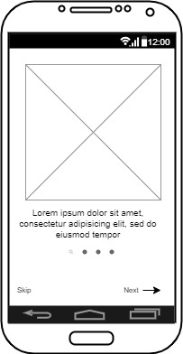
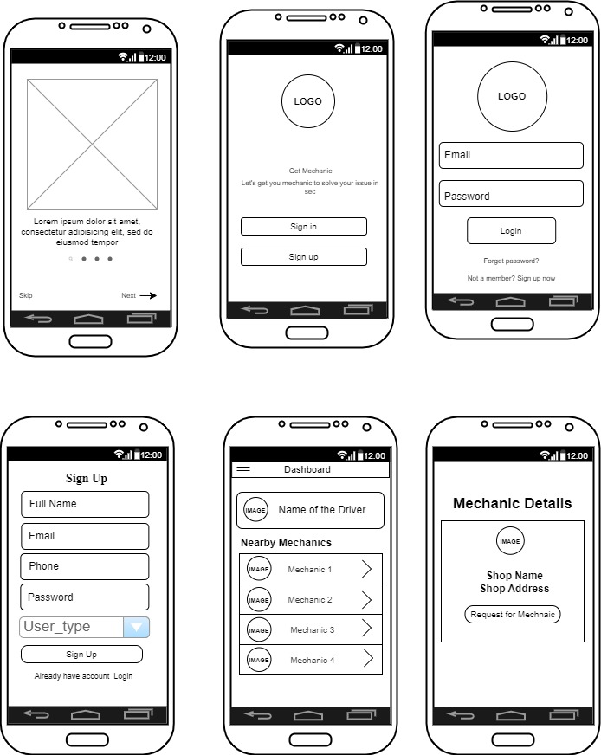

Figure 3.4 Onboard Screen
Figure 3.4.1 Landing Page

Figure 3.4.2 Register Page
Figure 3.4.3 Driver Home Page

Figure 3.4.4 Mechanic Request Page

Interface for Mechanic Users
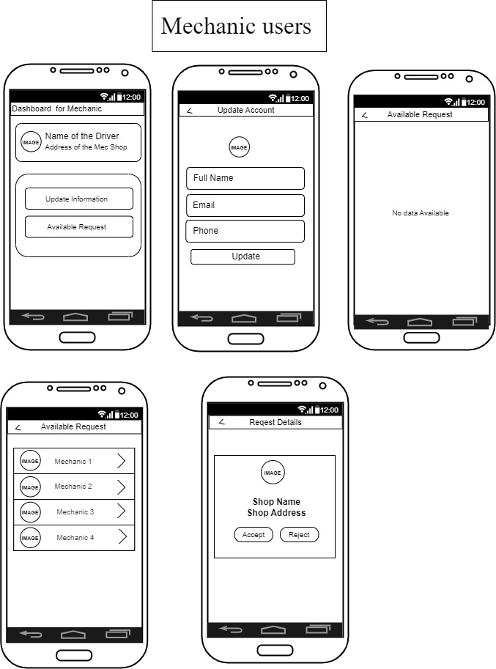
Figure 3.4.5 Mechanic Dashboard
Figure 3.4.6 Mechanic Update Page
Figure 3.4.7 Available Request
Figure 3.4.8 Request Page
3.5 System Requirement
For optimal performance, every system software developed has a specified system requirement on which it has been intended to run. This system require on other hand, are the minimum hardware and software requirements for the system smooth functioning.
3.5.1 Hardware Requirement
System hardware requirement
Minimum of 2GB RAM (Radom Access Memory)
Intel Dual Core Processor
250 GB HDD (Hard Disk Drive)
3.5.2 Software Requirement
The system software requirement are:
For the front end Flutter Dart
For the back end sqlite3
For the control end Django
3.6 Programming Language Used
This are the programming language use to build the application from scratch to the end of the project.
3.6.1 Flutter
Flutter is a mobile app SDK (software development kit) for building high-performance, high-fidelity apps for iOS and Android. With powerful graphics and animation libraries, the Flutter framework makes it easy to build user interfaces that react smoothly in response to touch.
Flutter is built on the Dart programming language and provides a fast development workflow with hot reloading, so you can quickly iterate on your code (Adservio, 2022).
Characteristics of Flutter include:
- Dart programming language: Flutter uses the Dart programming language, which is easy to learn and allows you to develop high-quality apps.
- Hot reload: Flutter's "hot reload" feature lets you quickly and easily make changes to your app without restarting it.
- Expressive and flexible UI: Flutter's UI elements are built using the same principles as Google's Material Design guidelines, giving you an expressive and flexible way to create beautiful apps.
- Native performance: Flutter apps are compiled to native code, giving you the best possible performance on both iOS and Android.
- Open source: Flutter is an open-source project, which means you can use it for free and contribute to the platform's development.
3.6.2 Uses of Flutter
You can tell that Flutter is a contemporary framework. It makes it much easier to design mobile applications. You'll notice how Flutter is different whether you've used Java, Swift, or React Native.
Flutter is a mobile app SDK that allows you to create high-quality native apps on iOS and Android. It is also the primary way to develop cross-platform apps with Google's new Fuchsia operating system (Adservio, 2022).
3.6.3 Benefits of Flutter
You may use Flutter to modify your code and see the results immediately. It is known as Hot-Reload. After you save, updating the program will only take a little while (Adservio, 2022).
There are several key benefits of using Flutter for developing mobile apps. They include:
- Flutter is fast: It uses a Dart programming language compiled into native code, meaning there is no need for a JavaScript bridge. This results in apps that are fast and responsive.
- Flutter creates cross-platform applications: The same code can be used to build apps for both iOS and Android devices from a single codebase rather than switching between different platforms.
- Flutter has a rich set of widgets: Widgets are the building blocks of Flutter apps, and a wide variety of them are available.
- Flutter is free: There are no licensing fees or charges for Flutter app development. This makes it an attractive option for startups and developers who want to create high-quality apps without spending much money.
- Easy debugging: The Dart programming language has excellent tools for debugging, like the Dart Analyzer and the DevTools suite. This makes it easy to find and fix bugs in Flutter apps.
3.6.4 Flutter Flexibility
You can easily create user interfaces that are attractive, quick, and responsive with the Flutter framework. Additionally, the framework is expandable, making it simple to include new features and functions.
When creating a Flutter app, you'll be working with what's called a "widget." Widgets are the basic building blocks of a Flutter app, and they're used to create both the visual components of an app (like buttons and text) and the functional elements (like Stateless Widgets) (Adservio, 2022).
There are two types of widgets:
- Stateless Widgets
- Stateful Widgets.
Stateless Widgets are those with no internal state. These are the most straightforward widgets and are often used for buttons or text (Adservio, 2022).
Stateful widgets can change over time and will have an impact on how the widget functions and appears. User input fields and animation controllers both frequently make use of stateful widgets (Adservio, 2022).
3.7 Python
Python is a popular computer programming language for creating websites and applications, automating processes, and performing data analysis. Python is a general-purpose language, which means it may be used to make a wide range of applications and isn't designed for any particular issues (Coursera, 2022).
3.7.1 Django
A high-level Python web framework called Django makes it possible to create safe and dependable websites quickly. Django, which was created by seasoned programmers, handles a lot of the complexity associated with website creation, allowing you to concentrate on building your app without having to invent the wheel. It's free and open source, has a vibrant community, excellent documentation, and a wide range of free and paid support options (MDN, 2022).

CHAPTER FOUR
SYSTEM IMPLEMENTATION AND EVALUATION
4.1 Introduction
In this chapter we focus on testing and develop the mobile app for on road vehicle breakdown assistance. This chapter involve the program; sample output and steps for system installation, to guide new users on how to perform task on the system, to ensure the functionality, accuracy and reliability of the app and validate it usefulness in detecting the nearness mechanics for the driver and also reduce stress of looking for mechanics for drivers when their car breakdown.
4.2 System Testing Evaluation
Conducting test for the developed system is more important, because is the only way to confirm that each interface of the app is working perfectly or to analyze problem in it and provide solutions to the problems. This project engaged both unit and integration testing to ensure effectiveness and productivity of design and to ensure that the project is working smoothly and is error-free. They are two ways in doing it which are unit testing and integration testing.
- Unit Testing
In this part every interface of the app are tested independently to ensure they are working effectively without errors. This section allows the users to verify the functionality of different modules of the app.
- Integration Testing
This part focus most in the interaction between different components and modules of the mobile app. It combine the individual unit tested in previous part together which the goal is to identify any inconsistencies or issues that may arise when different modules interact with each other.
4.3 System Conversion Plan
The system change plan of approach for transitioning from the existing system to the newly developed mobile app for road vehicle breakdown assistance detection. This section presents different approaches to system conversion, such as the pilot approach, parallel approach, and direct changeover. Each approach's advantages, disadvantages, and considerations are discussed to determine the most suitable plan for implementing the mobile app in a real-world.
4.4 System Installation
For every system that want to install the application need to follow the required steps to be able to install the application and run it smoothly.
- Open the project folder on Visual Studio Code, then select where you want to build the app either emulator/phone.
- Click on Run and select start debugging to build the app.
- Connect to any hotspot then open you Command Prompt type in “ipconfig” to get the hotspot IP address.
- Then go back to Visual Studio Code Click on terminal at the bottom of the visual studio code, then type in “cd name of the database folder” click on enter then the name of the folder will show in the terminal default code. Then type “pipenv shell” then it will show name of the backend with some code in a bracket and the default code of the terminal the repeat the first step then type “py manage.py runserver 192.168.136.227:8000” click enter button from the keyboard.
4.5 Security Measures
Since the scope of the mobile app is public, some of the information such as login, register are available to anyone who visits the app. But some other information and functionalities are restricted to some, which means the driver pages are different from the mechanics page and the activities carried out or perform are different. This restriction are carried out when register on the mobile app, the user will specified if he/she is a mechanic or driver to determine the kind of activity the user will carry out on the app.
4.6 Program Sample Outputs
These describe and give the pictorial representation of the software it shows and gives clear understanding of the design, and displays all the interfaces.

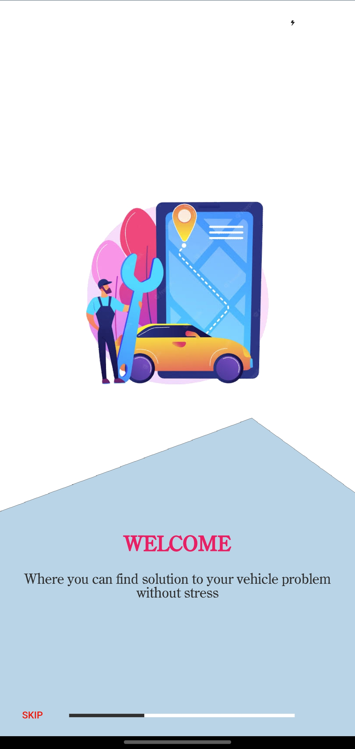
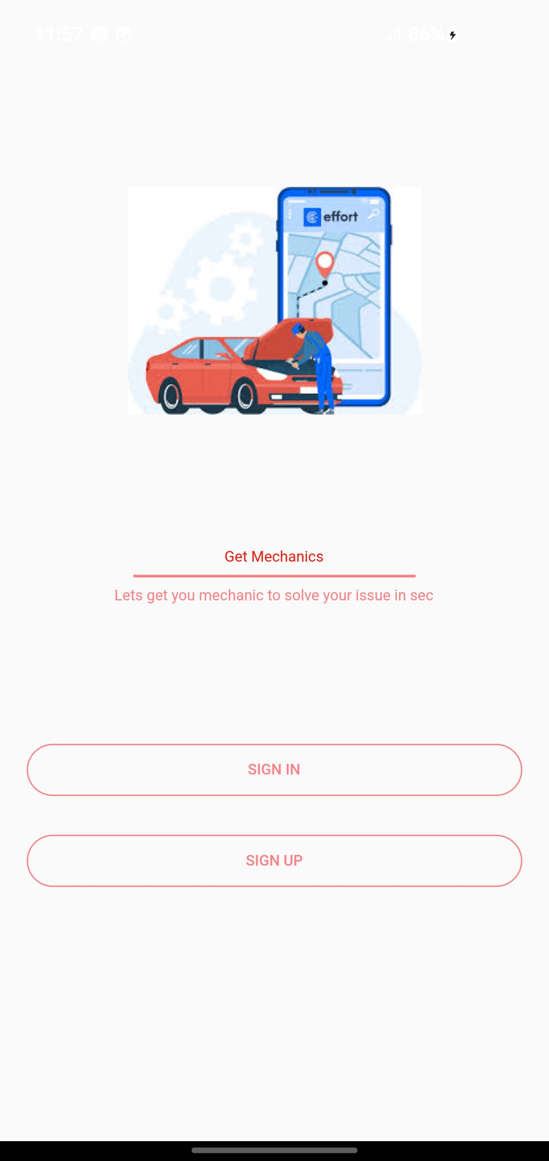

Fig: 4.6 Onboarding Screen

Fig: 4.6.1 Landing Screen

Fig 4.6 Onboarding Screen is the page that will appear for the first time new user install the application on their phone it brief them what the application is doing. Fig 4.6.1 Landing Screen is the next screen that it will take the user after the onboarding screen on the landing page that’s where the user can either sign in or sign up on the app to have full access to the application, if it’s the first time for the user on the app he/she have to sign up first so that we can know if he/she is driver or mechanic.
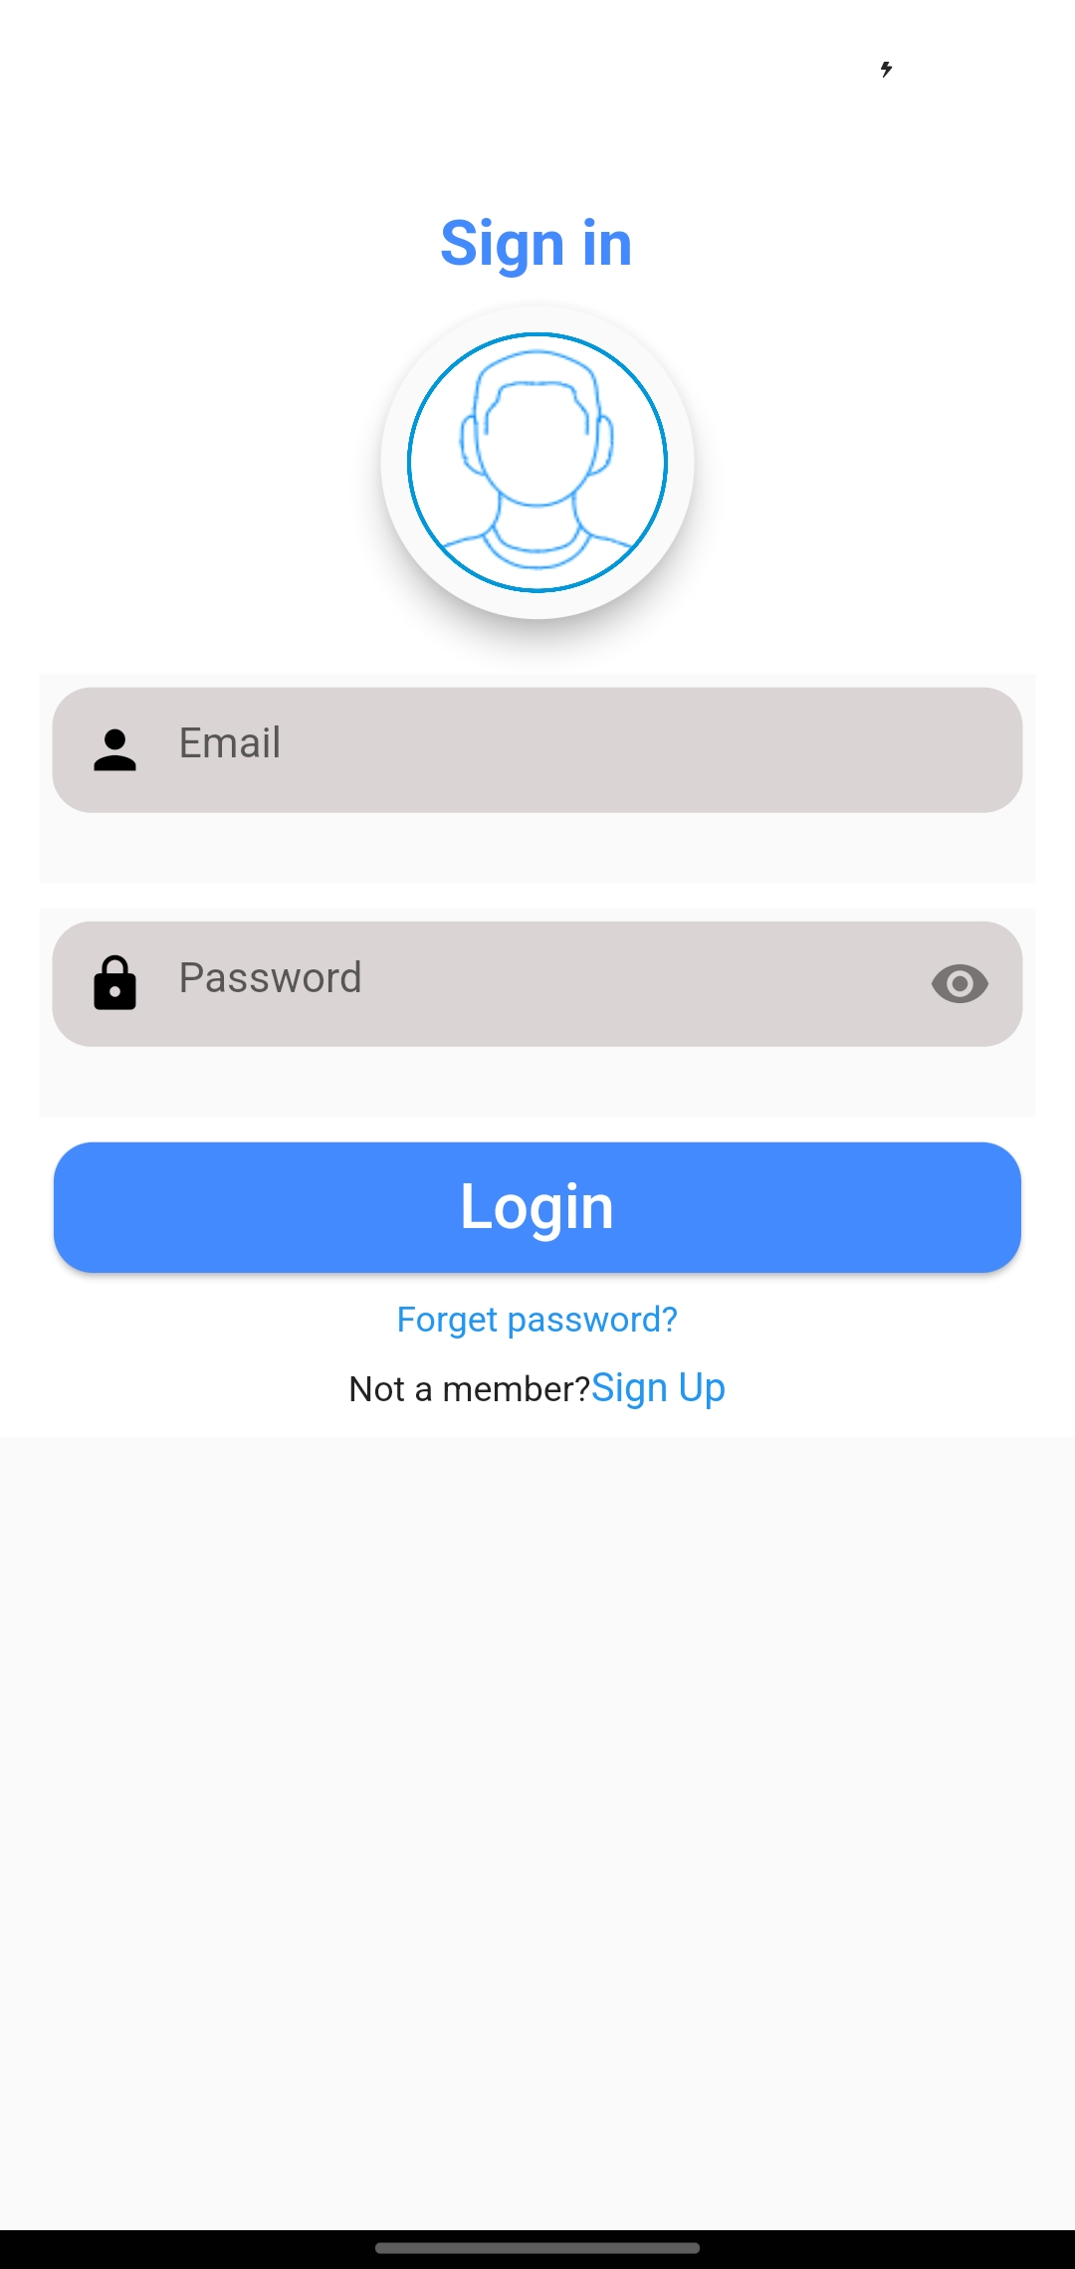
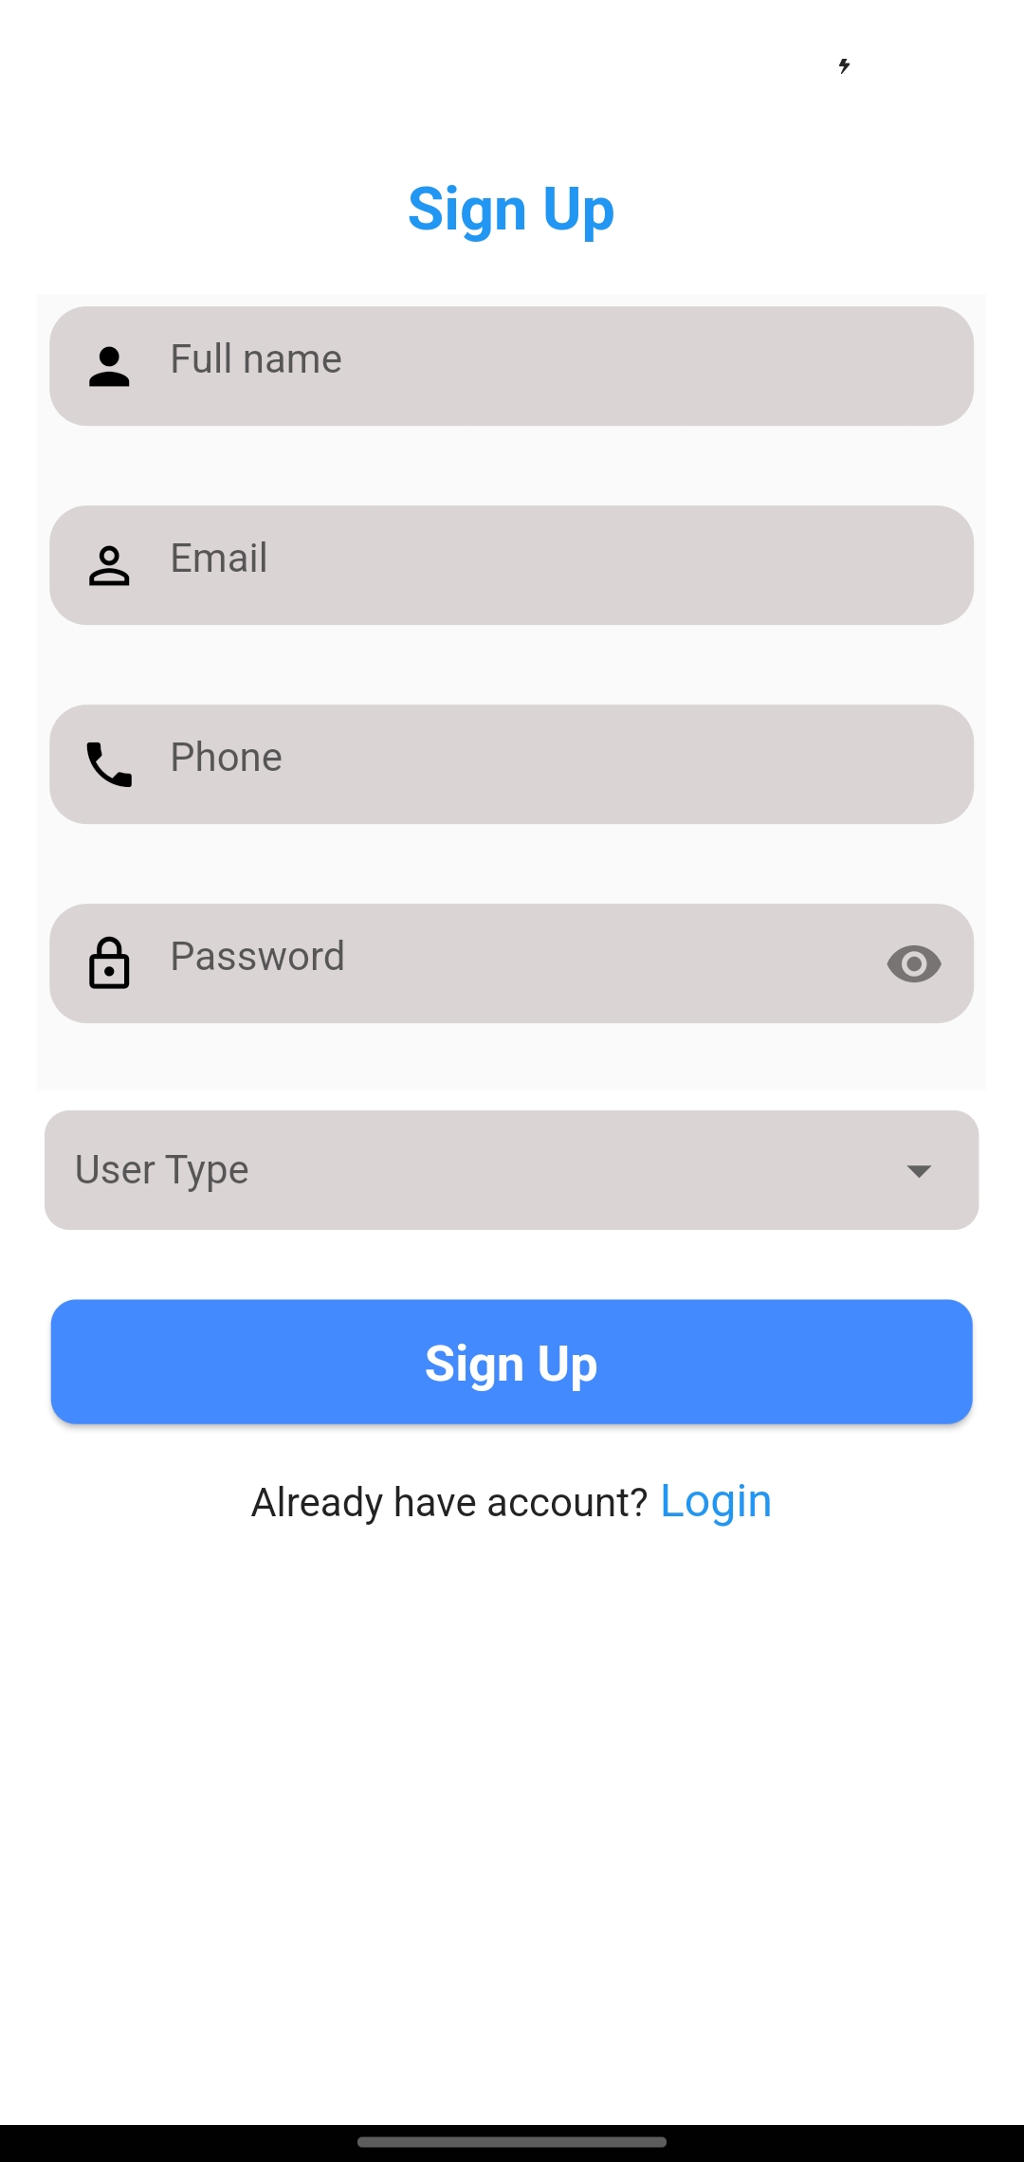
Fig: 4.6.2 Register Page

Fig: 4.6.3 Login Page

Fig 4.6.2 Register Page this is the page every new user have to visit before he/she can login this is where he/she we decide what he need the application for idea for business or for help, while fig 4.6.3 Login Page this is the page that will appear immediately after a user register, but user that have create account before and he/she want to use the app again he does not need to click on sign up again all he/she need to do is to click on sign in and it will take the user to the login page then the user input his login details then it will take the user to his/ her profile page then to provide his service.

Output for Mechanic Users
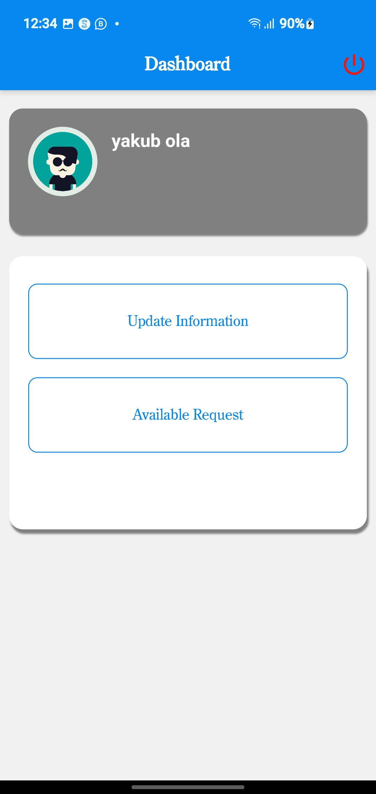
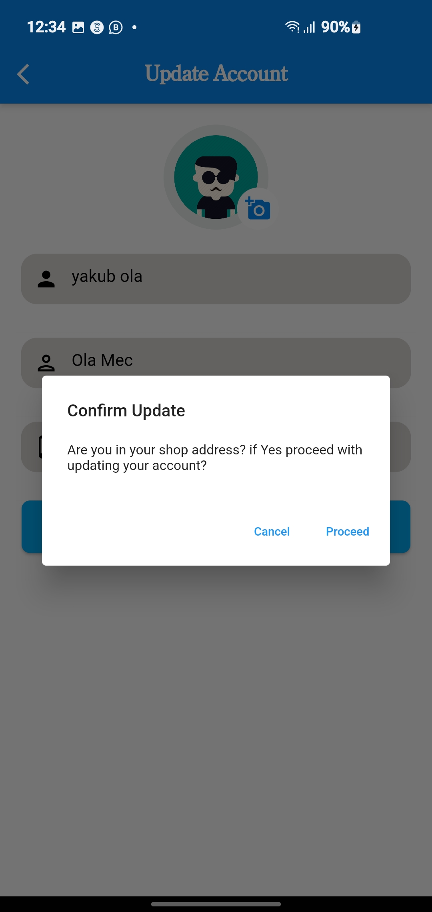

Fig: 4.6.5 Mechanic Update Page
Fig 4.6.4 Mechanic Dashboard

Fig 4.6.4 Mechanic Dashboard this is the place that will appear for every user that want to user the application for business that means when there are registering he/she select mechanic as their data type, so when they login it will display two button which the first one is to update their profile and the second one is to see all available request from driver, the mechanic have to update is data if he/she want drivers looking for mechanic around he’s route to ask for his servers. Fig 4.6.5 Update Page for Mechanics this is the place the mechanics will update their data but before they update the data they have to be in their shop because the geomapping use their current location as their shop address.
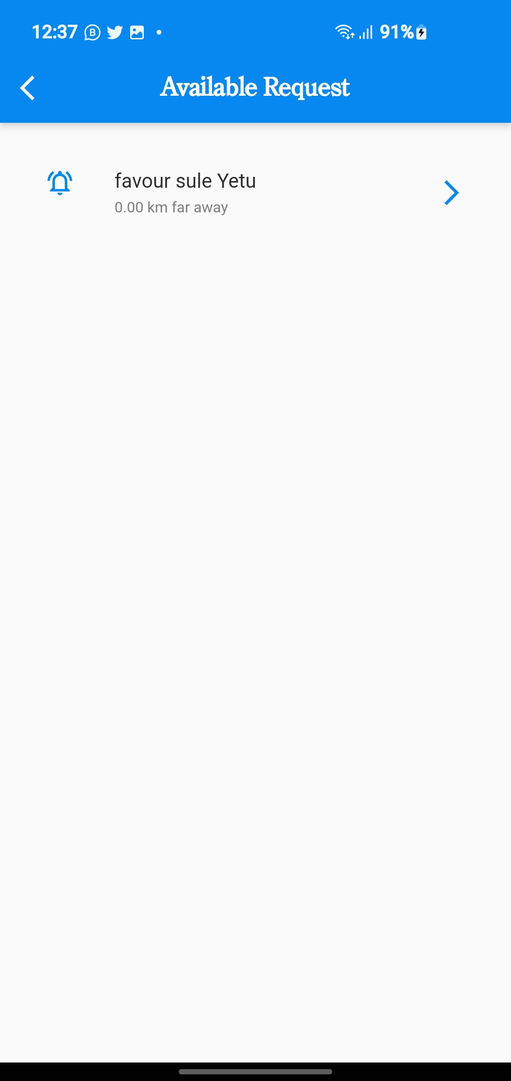
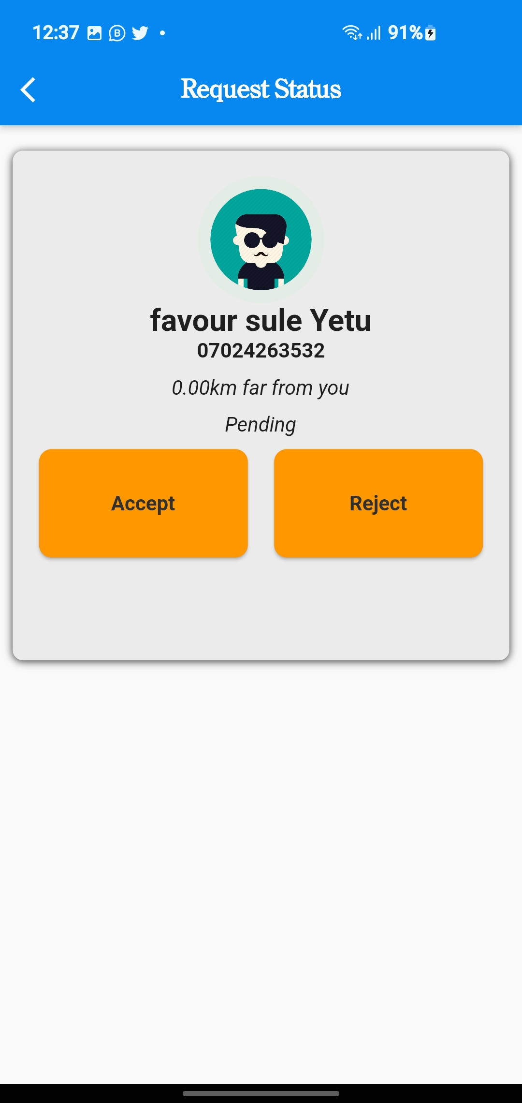

Fig 4.6.6 History Page
Fig 4.6.7 Status Page

Fig 4.6.6 History Page this is the place where every request send to the mechanic from different driver will appear so the mechanic is the one that will now select which one he/she want to attend to because it will show how far the driver his too he’s shop. Fig 4.6.7 Status Page this place that will show immediately the mechanic click on one of the request to either accept the request and reject it.

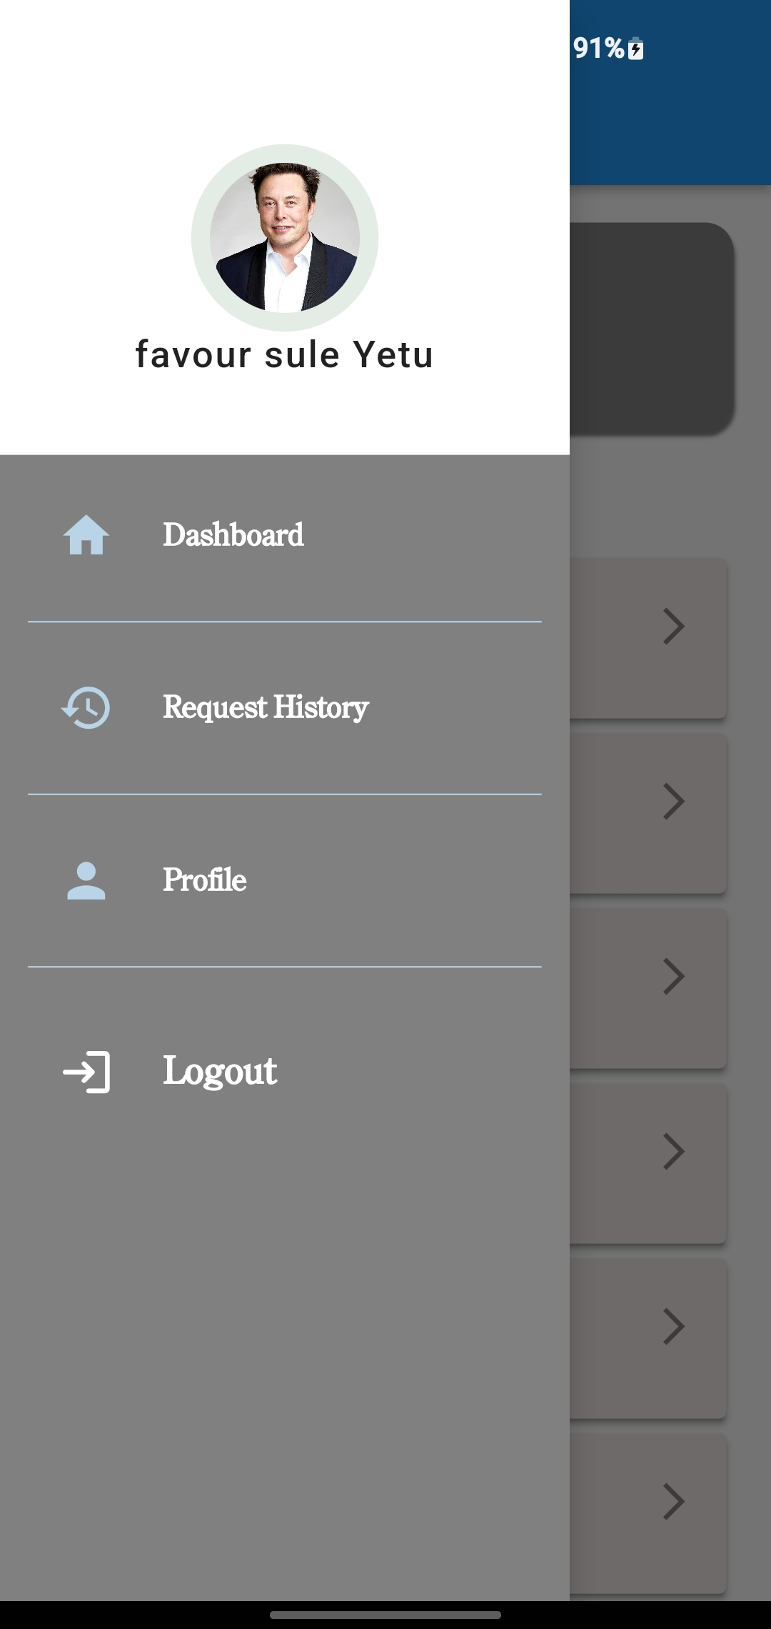
Output for Driver Users
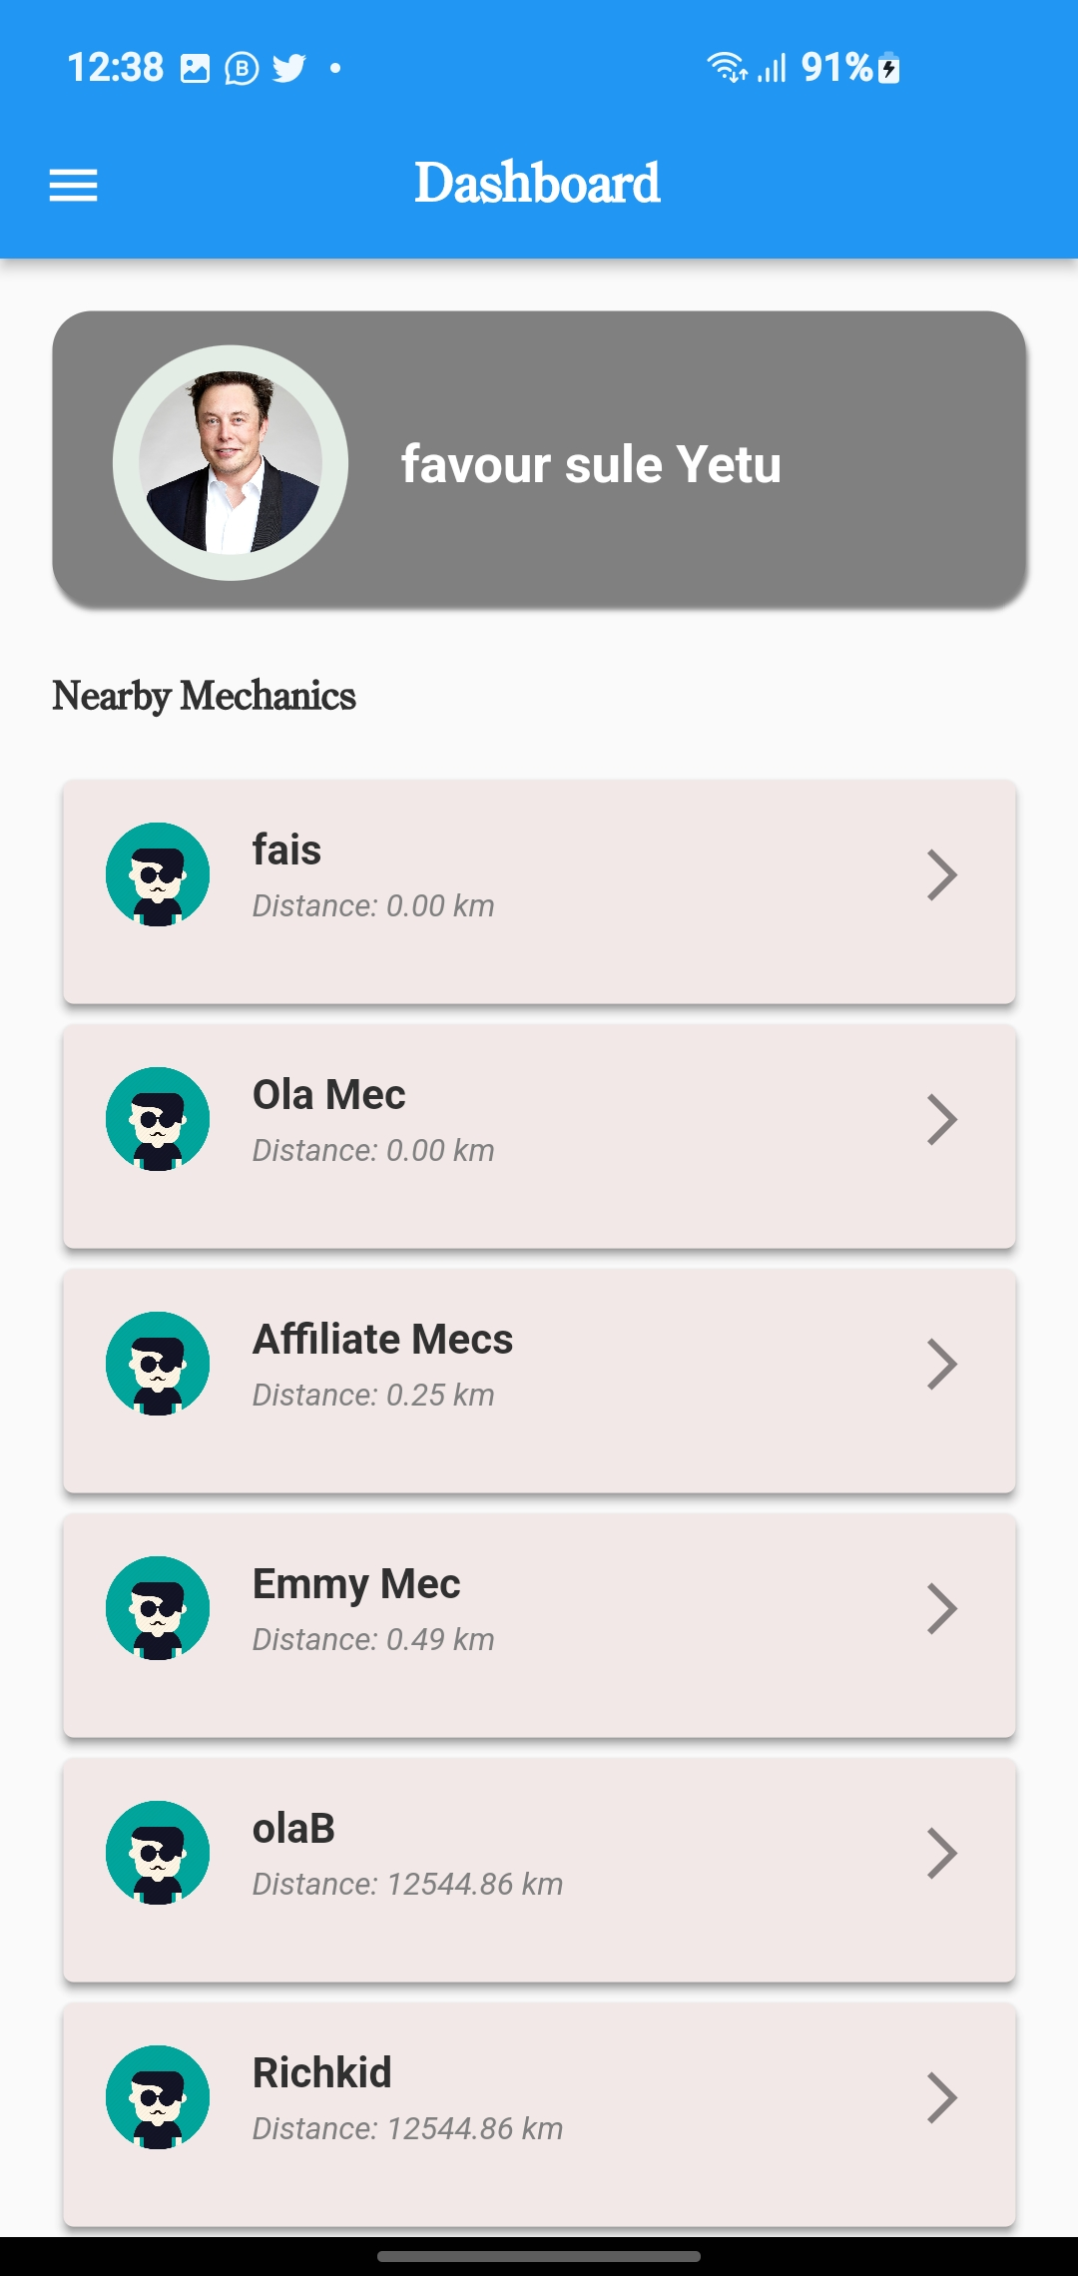

Fig 4.6.8 Driver Dashboard
Fig 4.6.9 Sidebar Interface
Fig 4.6.8 Driver Dashboard for every user that select driver has their user type when registering immediately they login this is how their dashboard will show if he/she have good network he/she name and picture will appear at the top and all nearby mechanic will show after the driver name, and the driver can easily click on any available mechanic to ask for their server if his/her car has fault. Fig 4.6.9 Sidebar this place show all the pages available in the driver interface they can easily navigate through.

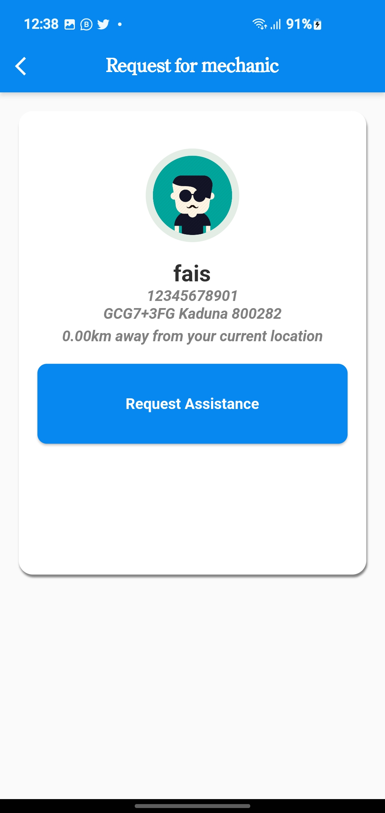
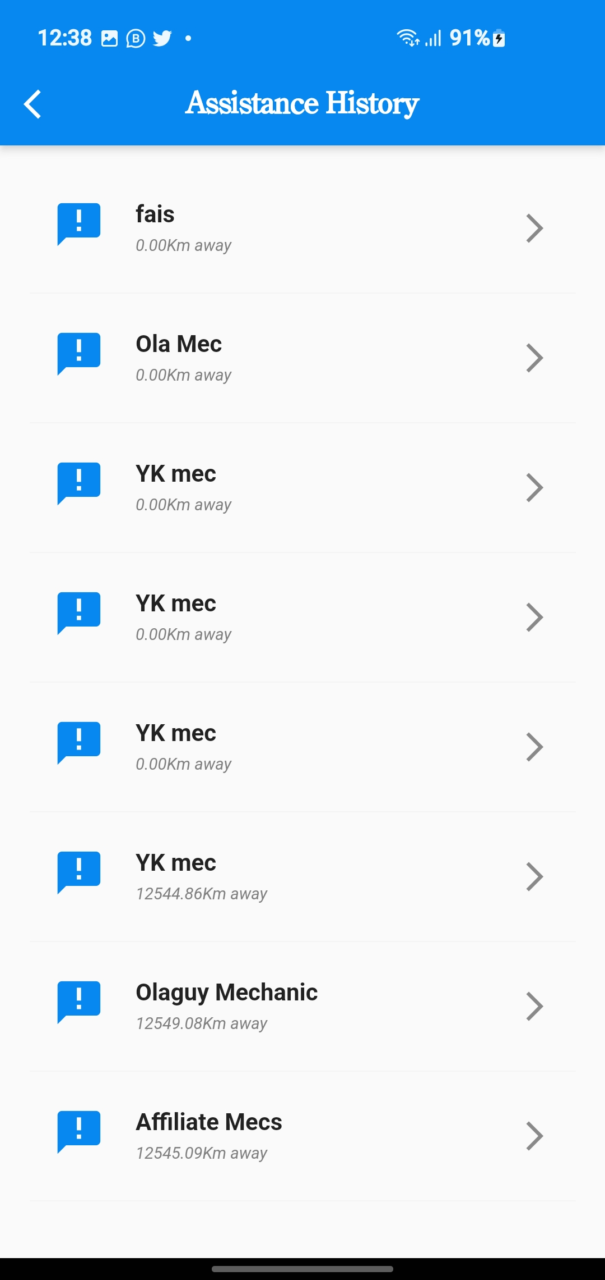

Fig 4.6.10 Driver request page
Fig 4.6.11 Driver request history

Fig 4.6.10 Driver request page this page will show immediately this driver select one mechanic to request for his servers here the driver will see the mechanic address, phone number and the shop name. Fig 4.6.11 Driver request history page here is the place all the request the driver has made to different mechanics will appear.

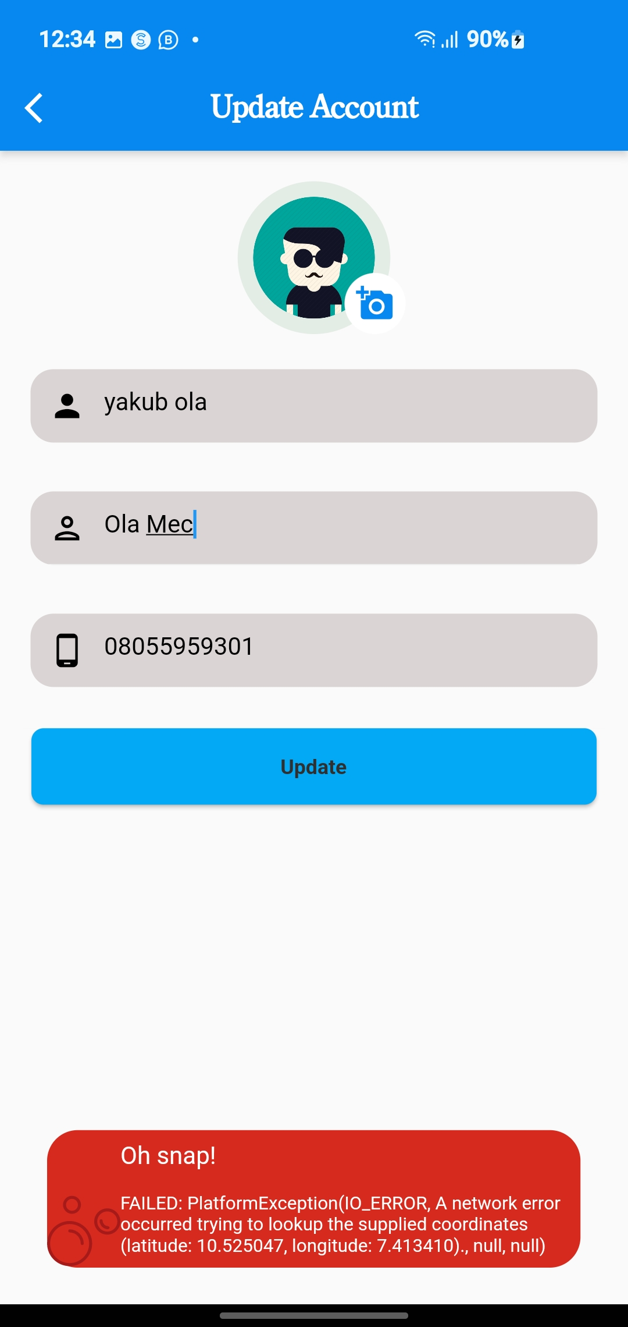
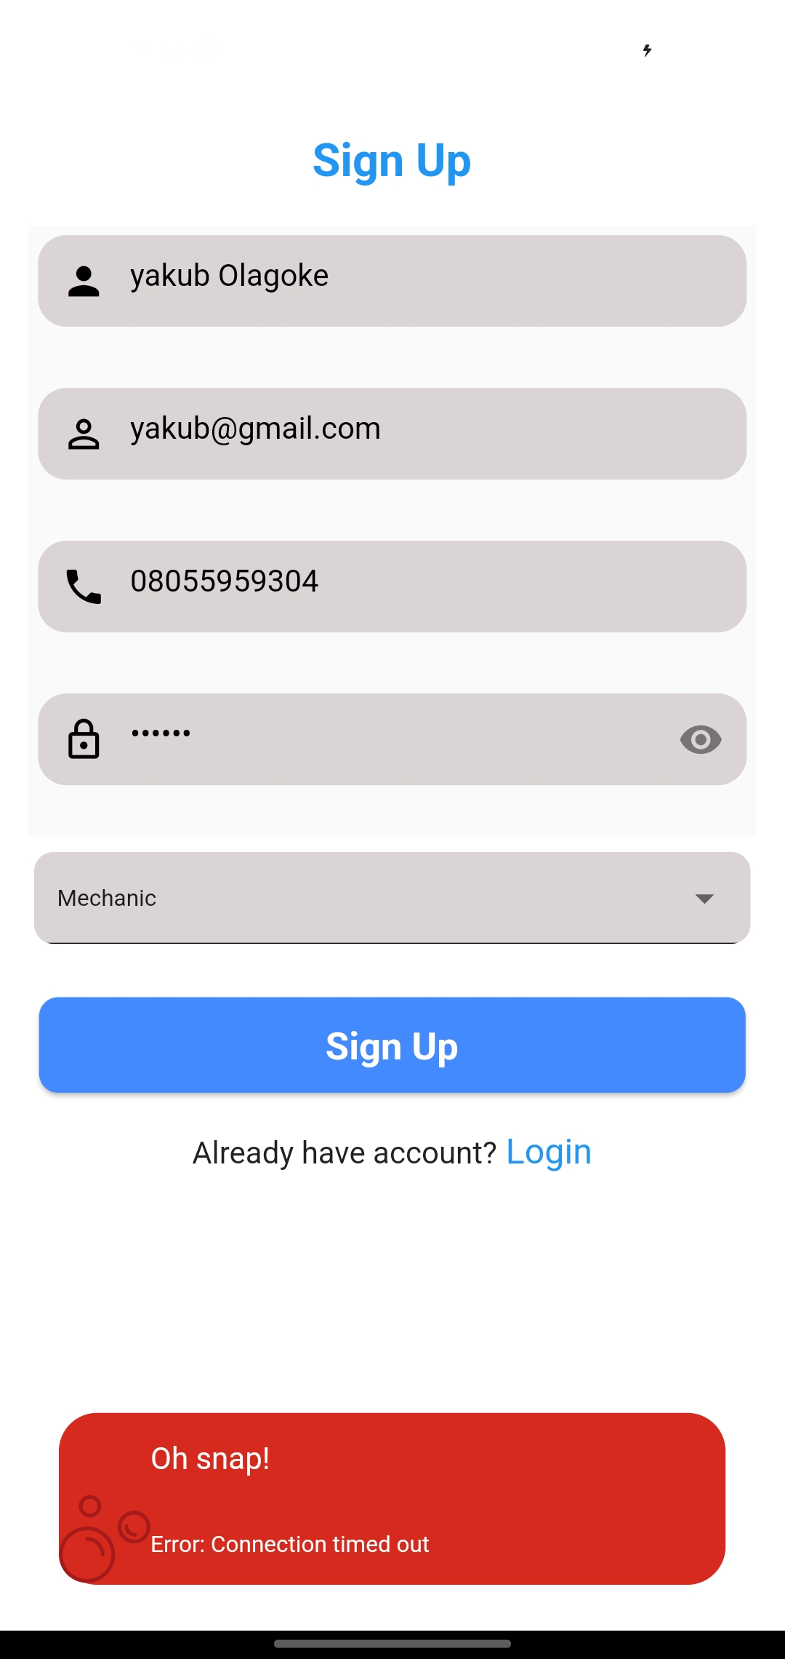

Fig 4.6.12 Connection Time Out
Fig 4.6.13 Update Profile Error

Fig 4.6.12 Connection Time Out this error normally occur when they is no connection between the python manage server and the application. Fig 4.6.13 Mechanic Update Profile page error message this error occur when the mechanic is trying to update details and they is no internet connect on the mobile phone he/she is using.

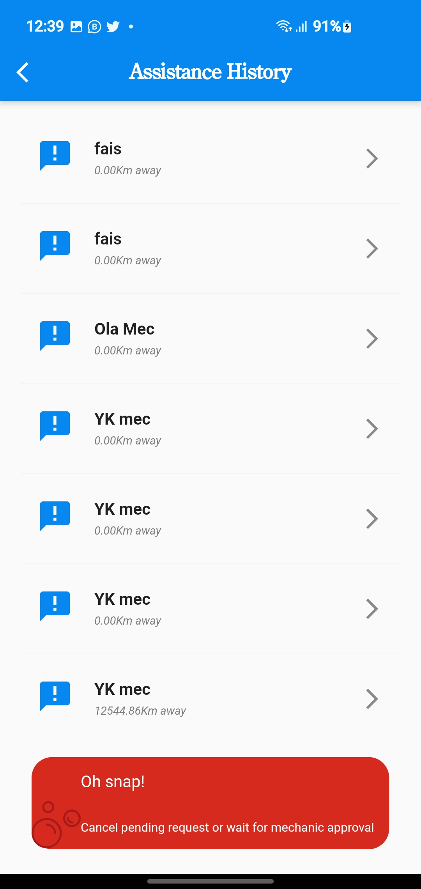

Fig 4.6.14 Pending Request Error
Fig 4.6.14 Pending request error this error occur when the driver has already request for mechanic before, and the mechanic did not respond on time or he does not have chance, the driver have to cancel the pending request if the mechanic does not reject the request before he/she can request for another nearby mechanic.
4.7 System Performance
This stage involves the execution of the newly proposed system. It entails testing and documentation of the program. For the system to run effectively throughout the time limit, it is strictly advisable to use good network connection when running the application.

CHAPTER FIVE
SUMMARY, CONCLUSION AND RECOMMENDATION
5.1 Summary
This project focus on the implementation of on road vehicle breakdown assistance. This system is proposed in order to provide assistance for drivers to locate mechanics easily without stress and also help mechanic to find new customers. With the implementation of the system drivers will not be going through much stress to locate driver anywhere anytime.
5.2 Recommendations
When it comes to road vehicle breakdown assistance, there are several things that can offer as services. Here are a few recommendations:
Find nearby feeling stations this should be included in the project incase members find their self in situation that lead to it.
Adding online payment to the project so that the driver can easily go for the payment price that is suitable for him or her.
When choosing a breakdown assistance provider, consider factors like coverage options, service quality, response times, pricing, and the provider's network coverage in your area. It can also be helpful to read customer reviews and compare the features and benefits of different providers to find the one that best meets your specific needs.
5.3 Conclusion
Road vehicle breakdown assistance plays a crucial role in ensuring the safety, convenience, and peace of mind of motorists. Based on the information available prompt and reliable support to motorists experiencing mechanical failures, or other emergencies. They offer timely response and aim to minimize disruptions in transportation and aim to alleviate this stress by providing a convenient and reliable solution. Knowing that help is just a phone call away can give drivers peace of mind, especially when traveling in unfamiliar areas.
REFERENCES
Adservio. (2022, August 30). What is Flutter and Its Advantages? https://www.adservio.fr/post/what-is-flutter-and-what-are-its-advantages
Adi Azlan Mohd Ali, Noor Azurati Ahmad, Shamsul Sahibuddin, Mohd Syahid Mohd Anuar (2017). Location-based Services: A study on applications and services. Advanced Informatics School, Universiti Teknologi Malaysia, Jalan Sultan Yahya Petra, 54100 Kuala Lumpur, Malaysia, 5(2)
Coursera. (2022, November 14). What Is Python Used For? A Beginner’s Guide. https://www.coursera.org/articles/what-is-python-used-for-a-beginners-guide-to-using-python
Deshmukh, P., Puraswani, S., Attal, D., Murhekar, G., katole, A., & Wankhade, M. (2020). REVIEW PAPER ON “ON ROAD VEHICLE BREAKDOWN ASSISTANCE SYSTEM.” International Journal of Engineering Applied Sciences and Technology, 4(11), 199–202.
Elakkiya, R., & Bavithra, M. (2020). ON ROAD VEHICLE BREAKDOWN SERVICES. International Journal or Creative Research Thoughts, 8(5), 1089–1093.
MDN. (2022, September 9). What is Django? https://developer.mozilla.org/en-US/docs/Learn/Server-side/Django/Introduction
Supare, H., Yadav, K., Solav, D., Budhbaware, A., & Daronde, S. (2020). ON ROAD VEHICLE ASSISTANCE SYSTEM. International Research Journal of Modernization in Engineering Technology and Science, 2(4).
Surya, G., & Barath, S. (2021). On-Road Vehicle Breakdown Assistance. International Journal of Research Publication and Reviews, 2(4), 103–105.
Krishna, L., Krishna, S., Amjad, S., Babu, U., & Surekha, T. (2021). A Vehicle Breakdown Service Provider System. International Journal of Scientific Research in Science and Technology, 7(4), 567–572. https://doi.org/10.32628/cseit2174129
Kárník, Jiří, and Jakub Streit. (2016). Location Based Services. Summary of Available Indoor
Location Techniques.
Khruahong, S, X Kong, K Sandrasegaran, and L Liu. (2018). Develop an Indoor Space
Ontology for Finding Lost Properties for Location-Based Service of Smart City. 18th International Symposium on Communication and Information.
Technology.

Harsha Supare., Kanchan Yadav., Divya Solav., Aniket Budhbaware., & Sahil Daronde. (2020). ON ROAD VEHICLE ASSISTANCE SYSTEM. International Research Journal of Modernization in Engineering Technology and Science, 02(04), 2582-5208. www.irjmets.com
Rinaldi, A M. 2009. A GIS-Based System for Electromagnetic Risk Management in Urban
Areas. Journal of Location Based.
Stülpnagel, R Von, and K Schmid. (2019). Risk Perception during Urban Cycling in
Volunteered Geographic Information and in the Lab: Effects of the Vista Space’s Spatial Properties. Journal of Location Based Services
Tiru, M, A Kuusik, M.-L. Lamp, and R Ahas. (2010). LBS in Marketing and Tourism
Management: Measuring Destination Loyalty with Mobile Positioning Data. Journal of Location Based Services.

APPENDICES
LANDING PAGE
import 'package:flutter/material.dart';
import 'package:flutter/services.dart';
import 'package:welcome/utils/constant.dart';
import 'package:get/get.dart';
import 'routes/routes.dart';
void main() {
SystemChrome.setSystemUIOverlayStyle(
const SystemUiOverlayStyle(statusBarColor: kTransparentColor),
);
runApp(MyApp());
}
class MyApp extends StatelessWidget {
@override
Widget build(BuildContext context) {
return GetMaterialApp(
debugShowCheckedModeBanner: false,
theme: ThemeData(
primaryColor: kPrimaryColor,
accentColor: kAccenstColor,
fontFamily: 'Schyuler',
),
initialRoute: Routes.splash,
getPages: getPages,
); } }
LOGIN PAGE
import 'package:flutter/material.dart';
import 'package:get/get.dart';
import 'package:welcome/components/inputField.dart';
import 'package:welcome/controllers/login_controller.dart';
import 'package:welcome/routes/routes.dart';
import 'package:welcome/utils/formValidation.dart';
class Login extends StatefulWidget {
@override
State<Login> createState() => _LoginState();
}
class _LoginState extends State<Login> {
bool _obscureText = true;
_toogle() {
setState(() {
_obscureText = !_obscureText;
});
}
LoginController loginController = Get.put(LoginController());
final _formKey = GlobalKey<FormState>();
@override
Widget build(BuildContext context) {
final size = MediaQuery.of(context).size;
return Scaffold(
body: Container(
color: Colors.white,
child: Stack(
children: [
Container(
padding: const EdgeInsets.only(top: 50.0),
child: SingleChildScrollView(
child: SizedBox(
width: size.width,
height: 500,
child: Form(
key: _formKey,
child: Padding(
padding: const EdgeInsets.symmetric(horizontal: 10),
child: Column(
mainAxisAlignment: MainAxisAlignment.spaceEvenly,
children: [
const Padding(
padding: EdgeInsets.only(
top: 20.0,
),
child: Text(
'Sign in',
style: TextStyle(
fontFamily: 'Schyuler',
fontSize: 30.0,
color: Colors.blueAccent,
fontWeight: FontWeight.bold,
), ), ),
inputField(
validator: FormValidation.validateEmail,
formController: loginController.emailController,
fieldIcon: const Icon(
Icons.person,
color: Colors.black,
),
hintText: 'Email',
obscure: false),
inputField(
fieldIcon:
const Icon(Icons.lock, color: Colors.black),
hintText: 'Password',
formController: loginController.passwordController,
validator: FormValidation.validatePassword,
obscure: _obscureText,
suffixIcon: GestureDetector(
onTap: () => _toogle(),
child: Icon(_obscureText
? Icons.visibility
: Icons.visibility_off),
), ),
SizedBox(
width: size.width * .9,
height: 50,
child: ElevatedButton(
style: ButtonStyle(
backgroundColor: MaterialStateProperty.all(
Colors.blueAccent),
// shape:MaterialStateProperty.all(outlinedBorder: OutlinedBorder(10.0)),
shape: MaterialStateProperty.all(
RoundedRectangleBorder(
borderRadius:
BorderRadius.circular(15.0))),
),
onPressed: () {
if (_formKey.currentState!.validate()) {
// Call login controller
loginController.verifyLogin();
} },
child: const Text(
'Login',
style: TextStyle(
fontSize: 30.0, fontFamily: 'Schyuler'),
), ], ), ), ); }}
DRIVER PAGE CODE
import 'package:flutter/material.dart';
import 'package:get/get.dart';
import 'package:welcome/components/defaultAppBar.dart';
import 'package:welcome/components/defaultBackButton.dart';
import 'package:welcome/controllers/approveRequestController.dart';
import 'package:welcome/controllers/cancelrequestController.dart';
import 'package:welcome/controllers/mecRequestDetailController.dart';
import 'package:welcome/utils/constant.dart';
class DriverHome extends StatefulWidget {
const DriverHome({super.key});
@override
State<DriverHome> createState() => _DriverHomeState();
}
class _DriverHomeState extends State<DriverHome> {
ProfileController profileController = Get.put(ProfileController());
GetNearbyMecController getNearbyMecController =
Get.put(GetNearbyMecController());
GetMecController getMecController = Get.put(GetMecController());
@override
Widget build(BuildContext context) {
final size = MediaQuery.of(context).size;
return WillPopScope(
onWillPop: () async {
showDialog(
context: context,
builder: (context) {
return AlertDialog(
title: const Text('Confirm Logout'),
content: const Text('Are you sure you want to logout?'),
actions: [
TextButton(
onPressed: () {
Navigator.pop(context);
},
return true;
},
child: Scaffold(
appBar: AppBar(
title: const Text(
'Dashboard',
style: TextStyle(
fontWeight: FontWeight.bold,
color: kWhiteColor,
fontFamily: 'Schuyler',
fontSize: 25.0,
), ),
body: RefreshIndicator(
onRefresh: () => getNearbyMecController.getNearbyMechanic(),
child: SingleChildScrollView(
child: Padding(
padding:
const EdgeInsets.symmetric(horizontal: 20.0, vertical: 20),
child: Column(
mainAxisAlignment: MainAxisAlignment.start,
crossAxisAlignment: CrossAxisAlignment.start,
children: [
Container(
height: size.height * .13,
width: size.width,
margin: const EdgeInsets.only(bottom: 10),
decoration: BoxDecoration(
borderRadius: BorderRadius.circular(15),
color: kLightColor,
boxShadow: const [
BoxShadow(
color: kLightColor,
blurRadius: 1.0,
offset: Offset(1, 3)),
], ),
padding: const EdgeInsets.only(top: 05.0, left: 10),
child: Obx(
() => profileController.isLoading.value
? const Center(child: CircularProgressIndicator())
: Row(
crossAxisAlignment: CrossAxisAlignment.center,
children: [
Padding(
padding: const EdgeInsets.only(
left: 8.0, top: 8, bottom: 8),
child: CircleAvatar(
backgroundColor:
const Color.fromARGB(255, 228, 236, 230),
maxRadius: 50,
minRadius: 50,
child: ClipOval(
child: Image.memory(
profileController.userProfile!.image,
height: 70,
width: 70,
fit: BoxFit.cover,
), ), ), ),
const SizedBox(
width: 15,
),
Text(
profileController.userProfile!.name,
softWrap: true,
style: const TextStyle(
color: kWhiteColor,
fontSize: 25,
fontFamily: 'Schyuler',
fontWeight: FontWeight.bold),
), ], ), ), ),
const Padding(
padding: EdgeInsets.symmetric(vertical: 20.0),
child: Text(
'Nearby Mechanics',
style: TextStyle(
fontSize: 18.0,
fontFamily: 'Schuyler',
fontWeight: FontWeight.bold,
color: kDarkColor,
), ), ),
SizedBox(
height: size.height * .7,
child: FutureBuilder<List<NearbyMechanic>?>(
future: getNearbyMecController.getNearbyMechanic(),
builder: (context, snapshot) {
if (snapshot.connectionState ==
ConnectionState.waiting) {
return const Center(
child: CircularProgressIndicator(),
);
} else if (snapshot.hasError) {
// If an error occurred
return Center(
child: Text(
'ERROR: ${snapshot.error}',
style: const TextStyle(
fontSize: 15.0,
fontFamily: 'Schuyler',
fontWeight: FontWeight.bold,
color: kDarkColor,
), ), );
} else if (snapshot.hasData) {
// If the data is available
List<NearbyMechanic> nearbyMechanics = snapshot.data!;
return ListView.builder(
physics: const ClampingScrollPhysics(),
padding: EdgeInsets.zero,
itemCount: nearbyMechanics.length,
itemBuilder: (context, index) {
final nearbyData = nearbyMechanics[index];
return Column(
children: [
Card(
elevation: 3,
shadowColor: kDarkColor,
color: kLightPinkColor,
child: SizedBox(
height: size.height * .1,
width: MediaQuery.of(context).size.width,
child: ListTile(
onTap: () {
getMecController.userID =
nearbyData.userId;
getMecController
.processGetNearbyMechanic();
},
leading: CircleAvatar(
backgroundColor: const Color.fromARGB(
255, 228, 236, 230),
maxRadius: 20,
minRadius: 20,
child: ClipOval(
child: Image.memory(
nearbyData.image,
height: 40,
width: 40,
fit: BoxFit.cover,
// alignment: Alignment.topRight,
), ), ),
trailing: const Icon(
Icons.arrow_forward_ios_outlined),
title: Text(
nearbyData.bizName,
style: const TextStyle(
fontSize: 20,
fontWeight: FontWeight.bold,
color: kDarkColor,
fontFamily: 'Schyuler',
), ),
subtitle: Text(
"Distance: ${nearbyData.distance} km",
softWrap: true,
style: const TextStyle(
fontFamily: 'Schyuler',
fontStyle: FontStyle.italic,
color: kLightColor,
fontSize: 15,
), ), ),),), ], ); }, );
} else {
// If there is no data available
return const Center(
child: Text(
'No data available!',
style: TextStyle(
fontSize: 15.0,
fontFamily: 'Schuyler',
fontWeight: FontWeight.bold,
color: kDarkColor,
), ), ); } }, ), ) ], ), ), ), ),
drawer: const NavigationDrawer(),
), ); }}
DRIVER REQUEST PAGE
import 'package:flutter/material.dart';
import 'package:get/get.dart';
import 'package:welcome/components/defaultAppBar.dart';
import 'package:welcome/components/defaultBackButton.dart';
import 'package:welcome/controllers/getMecController.dart';
import 'package:welcome/controllers/profile_controller.dart';
import 'package:welcome/controllers/requestMecController.dart';
import 'package:welcome/utils/constant.dart';
class Request_Mechanic extends StatefulWidget {
const Request_Mechanic({super.key});
@override
State<Request_Mechanic> createState() => _Request_MechanicState();
}
class _Request_MechanicState extends State<Request_Mechanic> {
GetMecController getMecController = Get.put(GetMecController());
ProfileController profileController = Get.put(ProfileController());
RequestMecController requestMecController = Get.put(RequestMecController());
@override
Widget build(BuildContext context) {
final size = MediaQuery.of(context).size;
return Scaffold(
appBar: const DefaultAppBar (
title: 'Request for mechanic',
child: DefaultBackButton(),
showLogoutButton: false,
),
body: Padding(
padding: const EdgeInsets.symmetric(vertical: 20, horizontal: 20),
child: Container(
height: size.height * .58,
width: size.width,
margin: const EdgeInsets.only(bottom: 10),
child: Padding(
padding: const EdgeInsets.symmetric(vertical: 20, horizontal: 20),
child: Column(
crossAxisAlignment: CrossAxisAlignment.center,
children: [
Padding(
padding: const EdgeInsets.symmetric(vertical: 20),
child: CircleAvatar(
backgroundColor: const Color.fromARGB(255, 228, 236, 230),
maxRadius: 50,
minRadius: 50,
child: ClipOval(
child: Image.memory(
getMecController.mec!.image,
height: 85,
width: 85,
fit: BoxFit.cover,
// alignment: Alignment.topRight,
), ), ), ),
Text(
getMecController.mec!.phone,
style: const TextStyle(
fontFamily: 'Schyuler',
fontSize: 20.0,
fontStyle: FontStyle.italic,
fontWeight: FontWeight.bold,
color: kLightColor,
), ),

const SizedBox(
height: 5,
), Text(
'${getMecController.mec!.distance}km away from your current location',
softWrap: true,
textAlign: TextAlign.center,
style: const TextStyle(
fontFamily: 'Schyuler',
fontSize: 20.0,
fontStyle: FontStyle.italic,
fontWeight: FontWeight.bold,
color: kLightColor,
), ),
Padding(
padding: const EdgeInsets.only(top: 20),
child: SizedBox(
width: size.width,
height: size.height * .10,
child: ElevatedButton(
style: ButtonStyle(
backgroundColor:
MaterialStateProperty.all(kFriendlyColor),
shape: MaterialStateProperty.all(
RoundedRectangleBorder(
borderRadius: BorderRadius.circular(10.0),
), ), ),
onPressed: () {
requestMecController.driverID =
profileController.userProfile!.userId;
requestMecController.mecID =
getMecController.mec!.userId;
requestMecController.processPendingRequest();
},
MECHANIC HOME PAGE
import 'package:flutter/material.dart';
import 'package:get/get.dart';
import 'package:welcome/components/defaultAppBar.dart';
import 'package:welcome/controllers/profile_controller.dart';
import 'package:welcome/controllers/receiveRequestController.dart';
import 'package:welcome/utils/constant.dart';
import '../../routes/routes.dart';
class MecHomePage extends StatelessWidget {
void _handleLogout(BuildContext context) {
showDialog(
context: context,
builder: (context) {
return AlertDialog(
title: const Text(
'Confirm Logout',
style: TextStyle(fontFamily: 'Schyuler'),
),
content: const Text(
'Are you sure you want to logout?',
style: TextStyle(
fontFamily: 'Schyuler',
), ),
actions: [
TextButton(
onPressed: () {
Navigator.pop(context);
},
child: const Text(
'Cancel',
style: TextStyle(
fontFamily: 'Schyuler',
),), ),
TextButton(
onPressed: () async {
Navigator.pop(context);
Get.back();
},
child: const Text(
'Logout',
style: TextStyle(
fontFamily: 'Schyuler',
), ), ), ); }, ); }
MecHomePage({super.key});
ProfileController profileController = Get.put(ProfileController());
ReceiveRequestController receiveRequestController =
Get.put(ReceiveRequestController());
DateTime timeBackPressed = DateTime.now();
@override
Widget build(BuildContext context) {
final size = MediaQuery.of(context).size;
return WillPopScope(
onWillPop: () async {
showDialog(
context: context,
builder: (context) {
return AlertDialog(
title: const Text(
'Confirm Logout',
style: TextStyle(
fontFamily: 'Schyuler',
), ),
content: const Text(
'Are you sure you want to logout?',
style: TextStyle(
fontFamily: 'Schyuler', ), ),
actions: [
TextButton(
onPressed: () {
Navigator.pop(context);
},
child: const Text(
'Cancel',
style: TextStyle(
fontFamily: 'Schyuler',
), ), ),
TextButton(
onPressed: () async {
Navigator.pop(context);
Get.back();
},
child: const Text(
'Logout',
style: TextStyle(
fontFamily: 'Schyuler',
), ), ), ], ); }, );
return true;
},
child: Scaffold(
backgroundColor: kAccenstColor,
appBar: DefaultAppBar(
title: 'Dashboard',
showLogoutButton: true,
onLogoutPressed: () => _handleLogout(context),
),
body: SingleChildScrollView(
child: Column(
children: [
Padding(
padding:
const EdgeInsets.only(top: 20.0, left: 10.0, right: 10.0),
child: Column(
children: [
Container(
width: size.width,
height: size.height * .16,
padding: const EdgeInsets.symmetric(
horizontal: 16.0, vertical: 20),
decoration: BoxDecoration(
borderRadius: BorderRadius.circular(15),
color: kLightColor,
boxShadow: const [
BoxShadow(
color: kLightColor,
blurRadius: 1.0,
offset: Offset(1, 3)),
], ),
child: Obx(
() => profileController.isLoading.value
? const Center(child: CircularProgressIndicator())
: Row(
mainAxisAlignment: MainAxisAlignment.center,
crossAxisAlignment: CrossAxisAlignment.start,
children: [
CircleAvatar(
backgroundColor: const Color.fromARGB(
255, 228, 236, 230),
maxRadius: 38,
minRadius: 38,
child: ClipOval(
child: Image.memory(
profileController.userProfile!.image,
height: 65,
width: 65,
fit: BoxFit.cover,
), ), ),
const SizedBox(width: 15),
Column(
crossAxisAlignment:
CrossAxisAlignment.start,
mainAxisAlignment: MainAxisAlignment.start,
children: [
Padding(
padding: const EdgeInsets.symmetric(
vertical: 3.0),
child: Text(
profileController
.userProfile!.bizName ??
profileController
.userProfile!.name,
textAlign: TextAlign.center,
style: const TextStyle(
fontSize: 25,
fontWeight: FontWeight.bold,
color: kWhiteColor,
fontFamily: 'Schyuler'),
), ),
const SizedBox(height: 2),
SizedBox(
width: size.width * .63,
child: Padding(
padding: const EdgeInsets.only(
right: 46.0),
child: Text(
profileController
.userProfile!.shopAddress ??
'',
softWrap: true,
textAlign: TextAlign.justify,
style: const TextStyle(
fontSize: 17.5,
fontWeight: FontWeight.bold,
color: kWhiteColor,
fontFamily: 'Schyuler'),
), ), ), ], ), ], ), ), ) ], ), ),
const SizedBox(height: 5),
Padding(
padding:
const EdgeInsets.only(top: 20.0, left: 10.0, right: 10.0),
child: Container(
height: size.height * .35,
width: size.width,
padding: const EdgeInsets.all(kFixedPadding),
decoration: BoxDecoration(
borderRadius: BorderRadius.circular(15),
color: kWhiteColor,
boxShadow: const [
BoxShadow(
color: kLightColor,
blurRadius: 1.0,
offset: Offset(2, 5)),
], ),
child: SizedBox(
width: size.width,
height: size.height * .3,
child: Column(
children: [
Container(
padding: const EdgeInsets.only(top: 20.0),
width: size.width * .85,
height: size.height * .12,
child: OutlinedButton(
style: ButtonStyle(
padding: MaterialStateProperty.all(
const EdgeInsets.symmetric(
vertical: kLessPadding),
),
side: MaterialStateProperty.all(
const BorderSide(
color: kFriendlyColor,
style: BorderStyle.solid),
),
shape: MaterialStateProperty.all(
RoundedRectangleBorder(
borderRadius: BorderRadius.circular(10.0),
), ), ),
onPressed: () => {
Get.toNamed(Routes.updatePage),
},
), ), ),
Container(
padding: const EdgeInsets.only(top: 20.0),
width: size.width * .85,
height: size.height * .12,
child: OutlinedButton(
style: ButtonStyle(
padding: MaterialStateProperty.all(
const EdgeInsets.symmetric(
vertical: kLessPadding),
),
side: MaterialStateProperty.all(
const BorderSide(
color: kFriendlyColor,
style: BorderStyle.solid),
),
shape: MaterialStateProperty.all(
RoundedRectangleBorder(
borderRadius: BorderRadius.circular(10.0),
), ), ),
onPressed: () => {
receiveRequestController.mecID =
profileController.userProfile!.userId,
Get.toNamed(Routes.requestPage),
},
child: const Text(
"Available Request",
style: TextStyle(
color: kFriendlyColor,
fontSize: 20.0,
fontFamily: 'Schuyler',
), ), ), ), ], ), ), ), ), ], ), ), ), ); }}
Ser

